The Hall of Philosophy - 1906
Chautauqua Institution (www.ciweb.org)
Chautauqua, New York
Designed by Edward B. Green, Architect
Buffalo, New York

Excerpts from the book
HIDDEN TREASURE: The Chautauqua Commission of Buffalo’s E.B. Green
By Ed Evans
Published 2005

Available through the Buffalo and Erie County Historical Society Museum Shop and the Chautauqua Book Store

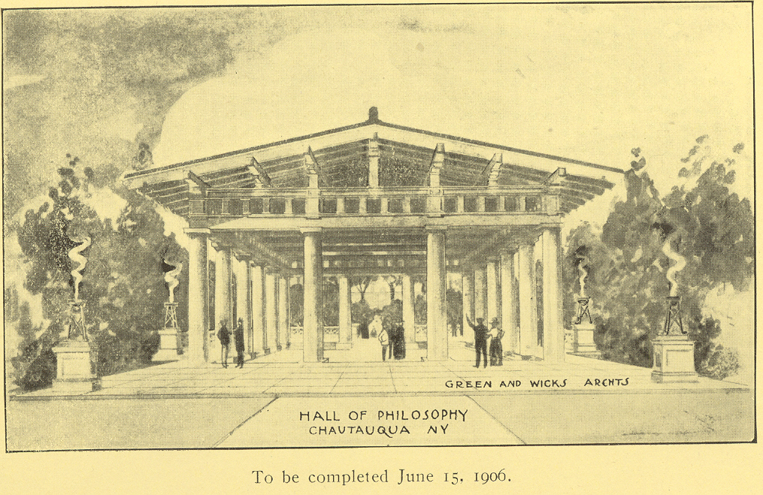

A rendering of the proposed Hall of Philosophy as it appeared in an Annual Report of the Chautauqua Board of Trustees. This was the first building designed for Chautauqua by Green and Wicks Architects, Buffalo, N.Y.
(Image-Chautauqua Institution Archives, Oliver Archives Center)

Below – A cross section view of the 1906 Green and Wicks design for the Hall of Philosophy. This is an excerpt from a set of Green and Wicks ink on waxed linen architectural drawings for the project. The Chautauqua Institution Archives has preserved three sets of ink on waxed linen drawings from the Green and Wicks firm for Chautauqua projects: The Hall of Philosophy, Chautauqua Post Office Block and Colonnade Building. Under the direction of the Chautauqua Archives, the drawings for the Hall of Philosophy and the Post Office were digitized in 2003 by The Campos Group, Tonawanda, N.Y. (Image-Chautauqua Institution Archives)

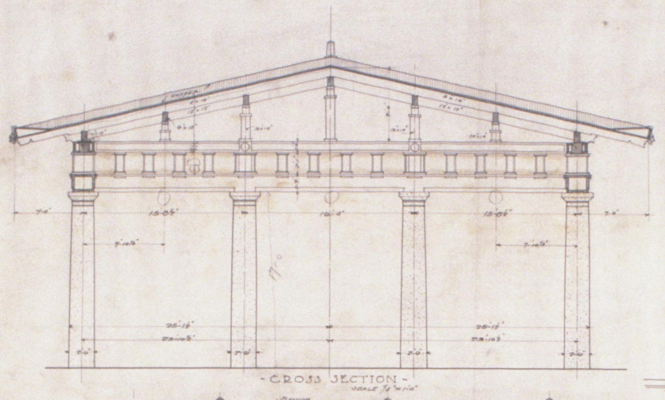

Photo 2005 – The Hall of Philosophy at Chautauqua, N.Y., designed by E.B. Green and completed in 1906. A century later the building is used almost daily during Chautauqua’s summer season for lectures, worship services, an occasional wedding and the annual Recognition Day ceremonies of the famous Chautauqua Literary and Scientific Circle.
(Photo – Robin Kinslow-Evans)

