National Register of Historic Places
Registration Form

This form is for use in nominating or requesting determinations for individual properties and districts. See instructions in How to Complete the National Register of Historic Places Registration Form (National Register Bulletin 16A). Complete each item by marking “x” in the appropriate box or by entering the information requested. If an item does not apply to the property being documented, enter “N/A” for “not applicable.” For functions, architectural classification, materials, and areas of significance, enter only categories and subcategories from the instructions. Place additional entries and narrative items on continuation sheets (NPS Form 10-900a). Use a typewriter, word processor, or computer to complete all items.

1. Name of Property

historic name PARKSIDE CANDY SHOPPE AND FACTORY
DRAFT

other names/site number
2. Location

street & number 3208 Main Street [ ] not for publication

city or town Buffalo [ ] vicinity

state New York code NY county Erie code 029 zip code 14214

3. State/Federal Agency Certification

As the designated authority under the National Historic Preservation Act, as amended, I hereby certify that this [X] nomination [ ] request for determination of eligibility meets the documentation standards for registering properties in the National Register of Historic Places and meets the procedural and professional requirements as set forth in 36 CFR Part 60. In my opinion, the property [X] meets [ ] does not meet the National Register criteria. I recommend that this property be considered significant [ ] nationally
[ ] statewide [X] locally. ([ ] see continuation sheet for additional comments.)

Signature of certifying official/Title Date

State or Federal agency and bureau

In my opinion, the property [ ] meets [ ] does not meet the National Register criteria. ([ ] see continuation sheet for additional comments.)

Signature of certifying official/Title Date

State or Federal agency and bureau

4. National Park Service Certification
I hereby certify that the property is: Signature of the Keeper date of action
[ ] entered in the National Register
[ ]see continuation sheet
[ ] determined eligible for the National Register
[ ] see continuation sheet
[ ] determined not eligible for the
National Register

[ ] removed from the National Register

[ ] other (explain)

5. Classification
Ownership of Property Category of Property Number of Resources within Property
(check as many boxes as apply) (Check only one box) (Do not include previously listed resources in the count)

[X] private [ ] building(s) Contributing Noncontributing
[ ] public-local [X] district 3 buildings
[ ] public-State [ ] site sites
[ ] public-Federal [ ] structure structures
[ ] object objects
3 0 TOTAL

Name of related multiple property listing Number of contributing resources previously
(Enter “N/A” if property is not part of a multiple property listing) listed in the National Register

N/A N/A

6. Function or Use

Historic Functions Current Functions
(enter categories from instructions) (Enter categories from instructions)

COMMERCE/TRADE/specialty store (candy shop) COMMERCE/TRADE/specialty store

(candy shop)

INDUSTRY/manufacturing facility (candy factory) INDUSTRY/manufacturing facility (candy factory)

7. Description

Architectural Classification Materials
(Enter categories from instructions) (Enter categories from instructions)

LATE 19th AND EARLY 20th CENTURY REVIVALS/ foundation stone

Arts and Crafts, Adams Revival walls brick; tile

roof asphalt composition

other cast stone

Narrative Description
(Describe the historic and current condition of the property on one or more continuation sheets)

8. Statement of Significance
Applicable National Register Criteria Areas of Significance:
(Mark “x” in one or more boxes for the criteria qualifying the property (Enter categories from instructions)
for National Register listing.)
Architecture
[X] A Property associated with events that have made
a significant contribution to the broad patterns Commerce
of our history.

[ ] B Property is associated with the lives of persons
significant in our past.

[X] C Property embodies the distinctive characteristics
of a type, period, or method of construction or that
represents the work of a master, or possesses Period of Significance:
high artistic values, or represents a significant and
distinguishable entity whose components lack 1925 – c.1955
individual distinction.

[ ] D Property has yielded, or is likely to yield, information Significant Dates:
important in prehistory or history.
1925, 1927, 1928, c.1955
Criteria Considerations
(Mark “x” in all boxes that apply.)

[ ] A owned by a religious institution or used for
religious purposes. Significant Person:

[ ] B removed from its original location N/A

[ ] C a birthplace or grave

[ ] D a cemetery
Cultural Affiliation:
[ ] E a reconstructed building, object, or structure
N/A
[ ] F a commemorative property

[ ] G less than 50 years of age or achieved significance Architect/Builder:
within the past 50 years
G. Morton Wolfe, architect

Narrative Statement of Significance
(Explain the significance of the property on one or more continuation sheets.)

9. Major Bibliographical References
Bibliography
(Cite the books, articles, and other sources used in preparing this form on one or more continuation sheets.)

Previous documentation on file (NPS): Primary location of additional data:
[ ] preliminary determination of individual listing (36 CFR 67) [ ] State Historic Preservation Office
has been requested.
[ ] previously listed in the National Register [ ] Other State agency
[ ] previously determined eligible by the National Register [ ] Federal Agency
[ ] designated a National Historic Landmark [ ] Local Government
[ ] recorded by historic American Building Survey [ ] University
# [ ] Other repository:
[ ] recorded by Historic American Engineering Record

#

10. Geographical Data

Acreage of Property

UTM References
(Place additional UTM references on a continuation sheet.)

1 | 1 | 8 | | | | | | | | | | | | | | | | 3 | 1 | 8 | | | | | | | | | | | | | | |
Zone Easting Northing Zone Easting Northing

2 | 1 | 8 | | | | | | | | | | | | | | | | 4 | 1 | 8 | | | | | | | | | | | | | | |

Verbal Boundary Description
(Describe the boundaries of the property on a continuation sheet.)

Boundary Justification
(Explain why the boundaries were selected on a continuation sheet.)
11. Form Prepared By

name/title Francis R. Kowsky and Martin Wachadlo [Edited by Jennifer Walkowski, NYSHPO]

organization Preservation Studios LLC date April 2015

street & number 60 Hedley Place telephone 716-440-0521

city or town Buffalo state NY zip code 14208

Additional Documentation
Submit the following items with the completed form:

Continuation Sheets

Maps
A USGS map (7.5 or 15 minute series) indicating the property’s location
A Sketch map for historic districts and properties having large acreage or numerous resources.

Photographs

Representative black and white photographs of the property.

Additional items
(Check with SHPO or FPO for any additional items)

Property Owner (Complete this item at the request of the SHPO or FPO)

name Philip Buffamonte

street & number 3208 Main Street telephone 716-833-7540

city or town Buffalo state NY zip code 14214

Paperwork Reduction Act Statement: This information is being collected for applications to the National Register of Historic Places to nominate properties for listing or determine eligibility for listing, to list properties, and to amend existing listings. Response to this request is required to obtain a benefit in accordance with the National Historic Preservation Act, as amended (16 U.S.C. 470 et seq.)

Estimated Burden Statement: public reporting burden for this form is estimated to average 18.1 hours per response including time for reviewing instructions, gathering and maintaining data, and completing and reviewing the form. Direct comments regarding this burden estimate or any aspect of this form to the Chief, Administrative Services Division, National Park Service, P.O. Box 37127, Washington, D.C. 20503
Narrative Description of Property

The Parkside Candy Shoppe and Factory is a group of three buildings located at the northwest corner of Main Street and West Winspear Avenue in the University Heights neighborhood of the City of Buffalo. All three buildings have a high degree of integrity and are still used for the purpose for which they were built. The most prominent component of the complex is the two-story brick and stone commercial Candy Shoppe building (1925-1927), located at the angled intersection of Main Street and West Winspear Avenue. This commercial building contains the Parkside Candy Shoppe’s primary retail showroom, as well as additional commercial and residential space. A two-story brick and tile daylight factory building, erected in two stages (1925-1927; 1928), is located immediately behind and to the west of the candy store building. A one-story, three-bay frame garage (1928) is located immediately to the west of the factory. A small parking lot on West Winspear Avenue fills the space behind the candy shop and next to the factory building. The neighborhood, which takes its name from the nearby South Campus of the University at Buffalo, is largely residential with commerce limited primarily to Main Street. The area is near the northeastern boundary of the city.

Setting

The southwest corner of Main Street and Winspear Avenue is occupied by a gas station (1970), the third on the site since 1925. The southeast corner was also the longtime site of a gas station, but it is now occupied by a parking lot fronting a one-story convenience store. On the northeast corner is a frame two-story, ground floor commercial building with apartments above. It was erected in 1911 and thus predates the Parkside Candy complex, as does the store and apartment building built in 1922, immediately north of the nominated property. Along both sides of Main Street in this vicinity, the streetscape is composed primarily of low-rise commercial buildings (some of which are converted houses) with stores or offices on the ground floor and apartments above. Most of these buildings date to the early decades of the twentieth century. The intersecting cross streets of the University Heights neighborhood are occupied by single and double family residences of similar vintage. A few blocks to the north on Main Street is the South Campus of the State University of New York at Buffalo, originally developed in the 1920s as the private University of Buffalo.

Candy Shoppe Building

Exterior: Principal Elevation

The store, office and apartment building is an irregularly shaped two-story brick and stone building occupying the obtuse angle at the northwest corner of Main Street and West Winspear Avenue. The principal elevation (east) faces Main Street. At ground level, it is a somewhat symmetrical composition with a conspicuous door between the two storefronts. This entrance, framed in masonry with Classical details, and which apparently retains the original wooden door and transom, opens onto a staircase that leads to the second floor apartments and offices. The doorway cornice projects over a dentil course with a row of egg and dart molding below and rests on a pair of brackets with guttae at their bases. Above the architrave, an oval cartouche proudly bears a capital letter “P” surmounted by an anthemion and flanked by a pair of cornucopia.

The two storefronts to either side of the center entrance feature large plate glass windows on gray masonry bulkheads. Iron bars protect basement openings (now blocked) beneath each display window. A shallow stone cornice extends across both of the storefronts and is surmounted by an egg and dart molding beneath a dentil course. The top of this cornice serves as the sill course for a row of eight windows regularly spaced between brick piers. Each of the piers is crowned by a cast stone oval cartouche containing the capital letter “P.” Each of the openings contains six-over-six double-hung metal sash windows that are modern replacements for the original wooden fenestration. There is a three-light transom above each window. Immediately above the windows at the lintel level is a flat architrave topped by an egg and dart molding surmounting a dentil course with a shallow projecting cornice above, all rendered in metal painted dark brown. Above the cornice, a brick parapet with stone coping borders the building’s flat roof.

At the southern corner of the east façade, the candy store entranceway announces the building’s more important commercial space. It consists of a large plate glass display window facing Main Street and a recessed entranceway to the left of that leading into candy shop. The recessed area of this entrance is flanked by plate glass showcases that feature seasonal presentations related to the sale of candy. Beige and tan tile flooring and double wooden and plate glass entrance doors with brass fittings welcome customers to the delightful interior.

On the front of the building, a large chocolate colored metal and neon sign occupies the space between the top of the display window and the first story cornice. Prominently proclaiming the name of the establishment, it wraps itself around the West Winspear Avenue (south) side of the building as well. The name “Parkside Candies” is repeated on the Winspear Avenue and Main Street sides of the festive placard, which, although not original to the building, has long been the identifying feature of the exterior. Now badly deteriorated--the neon tubes no longer function—the signboard appears to date to the 1950s. No records, however, have been found related to its installation. This date has been established based on the style of its design and lettering.

The northern commercial rental space, which is currently leased by a wholesale spice dealer, is marked by two plate glass windows on either side of a recessed entrance. These window showcases are curtained off from public view.

South Elevation

The two-story southern elevation, facing West Winspear Avenue, continues elements of the Main Street elevation. The stone-and-plate-glass showcase with signboard above that forms a unit with the entrance to the candy shop occupies the eastern end of the south elevation. A more somber note is struck by a bronze plaque affixed to the wall adjacent to the showcase commemorating fallen fighters in World War II. The remainder of the first floor elevation is blank, buff colored textured brick, except for four small windows with stone sills at the western end. (These light an interior kitchen.) A shallow stone cornice extends across the first story and defines the second level. An egg and dart molding and dentil course ornaments the underside of this cornice. Above this cornice, a stone sill course continues from the Main Street elevation. It supports a row of ten regularly spaced windows that alternate with brick piers. Each of the brick piers is topped with a cream-colored masonry oval cartouche bearing a majuscule “P.” There is no window in the westernmost bay; it is filled with a recessed brick panel that appears to be original to the building. The seven eastern bays have recent six-over-six metal double-hung sash windows with three transoms above; the three western windows have similar sash but no transoms. This area above these windows is filled with brick. Immediately above the windows, a dark brown metal architrave and cornice runs the full length of the elevation. This feature represents a continuation of the same feature present on the Main Street elevation. Above this cornice, a brick parapet with stone coping conceals the flat roof.

West and North Elevations

The west and north sides of the building have no architectural features. (A small exception to this is the two-foot strip at the south corner of the west elevation that repeats the elements of the south elevation.) The remainder of this rear side of the building is faced in common brick painted red. Irregularly sized windows with stone sills and utilitarian doors are placed according to interior functions in this elevation. A square brick chimney projects at approximately the center of the elevation. A modern wooden balcony addition with metal staircase is located on the west second story immediately north of the chimney. The north elevation, which is inches away from the neighboring building, is composed of fireproof tile and brick and has no openings in it.

Interior

The ground floor layout consists of two commercial spaces divided by a staircase leading from the street to a second floor transverse corridor. To the right along this corridor is a small office that overlooks Main Street; to the left, the corridor leads to another office that also overlooks Main Street and to a third office that overlooks West Winspear Avenue. A second corridor leads from the juncture of the second floor staircase landing and the first corridor to the back of the building. It gives access to a two-bedroom apartment overlooking West Winspear Avenue (on the south side of the building) and a one-bedroom apartment overlooking the rear (west side) of the building. On the ground floor, a rental office on the north side of the entrance to the second floor has a central doorway recessed between two, large, plate glass showcases and leading into the large single room of the interior. To the left of the doorway to the second floor is a large plate glass showcase for the candy store and beyond that a recessed doorway leading to the entrance to the candy shop and restaurant.

Candy Shop and Restaurant

The principal interior space in the building is the candy shop and restaurant in the southeast portion of the ground floor. This large oval space with a domed ceiling retains its as-built appearance, reflecting its original Adams Revival decoration. Customers enter this brightly lit, colorful room from the street through the original paired wooden doors at the east end of the long axis of the oval. The windowless space is surrounded by a series of alternating, narrow, round and wide segmental-arched openings framed with unpainted walnut moldings. These dark moldings contrast pleasantly with the pale, “pistachio” green color of the lower level of the room. Plaster pilasters filled with grotesque decorative reliefs and topped by stylized Corinthian capitals separate the arched areas from each other. A distinctive feature of the capitals is the small, identical feminine face that peers into the room from between the volutes. Perforated gold metal sconces of recent vintage mounted beneath the capitals have replaced original candelabra sconces but still cast soft light upon the little faces.

Starting at the left or south side of the entrance as one enters the room, the sixteen bays of the arcade are organized in the following order. Along the south wall is a wide segmental arch with recessed wooden paneling and slightly projecting wainscoting; a narrow round arch containing a stationary mirrored panel; a wide segmental-arched opening sheltering a wooden counter that projects into the room and from which ice cream is served (on the wall behind the counter is an original wall cupboard for holding glassware); a narrow round arched opening leading to the kitchen in the southwest corner of the building and to the area behind the ice cream counter; a wide segmental arch filled with recessed wood paneling on which is hung a large oil painting, dated 1939, by local artist Carlo Nista (of the Kaiser family farm in East Aurora); and a narrow round arch filled with a mirrored glass door leading to a restroom. Along the west wall is a wider segmental arch sheltering a seating alcove (this element is opposite the entrance on the long axis of the oval) in which there is a curved upholstered bench beneath a segmentally arched leaded glass casement window and a narrow round arch giving access to the service area along the entire eastern wall of the oval room. Along the north wall is a wide segmental arch sheltering two glass candy display cases; a narrow round arch giving access to the service area behind the candy cases; a wide segmental arch sheltering two glass candy display cases; a narrow round arch with a Dutch door giving access to the service area behind the candy cases, and a wide segmental arch sheltering two glass candy display cases. Along the north wall is a narrow round arch filled with a mirrored glass door opening into a small closet; a wide segmental arch sheltering the main entrance with two wood and glass doors; and a narrow round arch containing a mirrored glass door that opens into a small closet.

The pilasters of the arcade support a green entablature that extends around the circumference of the space and is ornamented with gold low relief urns alternating with swags. Above this border, a shallow cornice supported on small brackets projects into the room. A line of diminutive urns alternating with swags crowns this cornice and conceals an area of indirect lighting behind it. The ceiling dome rises without visible support from behind this recessed light ledge, as if hovering over the room. The light from concealed bulbs bathes the shallow dome in a soft glow and casts the acroterion-like urns and swags into sharp relief.

The dome itself is made of plaster painted a light cream color. In the manner of Robert Adam, it is ornamented with Classical moldings and decorative designs in low relief arranged in an overall symmetrical pattern. The decoration features an outer border of lyres linked by garlands. From each lyre a straight line of small lilies extends inward to eight symmetrically disposed rectangular panels. Each of these frames a pair of sphinxes facing a vase. These panels are joined to another by delicate garlands that border a central recessed oval oculus. This oculus is itself defined by a series of handsome moldings. The middle of the oculus holds a sunburst pattern in low relief. Unfortunately, a large circular air-conditioning ventilator obscures much of this decorative feature.

This handsome sales room preserves many of its original furnishings and fixtures. Three permanently fixed, metal, torchère-style floor lamps are aligned along the long axis of the room. Each of the seven-foot-tall lamp stands support a bowl consisting of six curved, white frosted glass panes concealing electric lights. Open at the top, the uplifted bowls shed additional light on the dome. The central lamp stand is directly under the oculus. These freestanding lamps also have grilled panels in their bases that provided seasonally warm and/or cool air to the sales space. In the center alcove of the south side of the room is the original soda fountain counter. Behind it is the original walnut buffet and shelves for glassware. Both naturally finished pieces also are detailed with pilasters, urns and swags similar to those found throughout the room. Three alcoves along the north end of the room contain the original natural walnut-base display cases. Most of the tables and chairs used to serve diners are also original, as are the faux marble baseboards and marbleized cream and black linoleum tiles on the floor.

Ground Floor Rental Space

The retail rental space on the north side of the ground floor of the building is a simple rectangular room approximately 40 feet wide and running the depth of the building. The only architectural feature of importance in this room is the stamped metal ceiling that dates from the time of the construction of the building. The back portion of this room has been partitioned off by a modern plasterboard wall to create a back room of approximately 20 feet in depth. This large, high-ceilinged room is entered directly from the street by a central entrance with a single wood and plate glass door.

The Second Floor: Two Apartments and Three Small Offices

A steep staircase rising from the center entrance on Main Street accesses the second floor. This staircase ends at the top of a T-shaped corridor, which gives access to all the second floor spaces. Unpainted woodwork in the hall frames doorways and large windows in the walls that provide additional light to the office spaces. The offices also have windows overlooking the street on the east and south side. These offices are very simply finished. The east-west portion of the hall leads to two apartments in the rear of the second floor. These apartments contain a living room and a dining room separated by French doors, adjacent kitchen with original sink and buffet, bathroom and two small bedrooms. The woodwork in the principal spaces is naturally finished. At one time, the original owner of the building inhabited one of these apartments.

Factory Building

Exterior

The factory is a two-story brick and tile daylight building with a flat roof. It is located directly behind the store, office and apartment building, at the north end of the lot. The principal elevation faces south, overlooking the parking lot and the sidewalk on West Winspear Avenue. This is the only elevation that is visible to the public. The factory is built in two sections. The original four-bay segment was constructed in 1925-1927 and is closest to, and perpendicular to, the candy store building. The second section was built a year later, in 1928, at the western end of the original building from which it extends at an approximate 45-degree angle. Above the second floor of the earlier section of the factory there is a painted horizontal green band, in which, in yellow lettering, appear the words “Parkside Candy Co. Inc.” A similar band fills the space between the first and second floors, with the words “Manufacturers of Quality Candies.” This original painted signage was restored in the summer of 2014 when the entire exterior of the building received a fresh coat of paint.

The original section of the factory has four large rectangular openings on each floor. The three westernmost openings are approximately twice the width of the last bay on the east. All windows feature stone sills. The first story windows have one-over-one double-hung sash windows in groups of four, but only the easternmost opening is exposed; the others have been boarded over. The windows on the second story are almost entirely filled with glass block. A loading dock, which can be reached from the parking lot by a flight of steps, projects from the eastern half of building. A shed roof supported by three square wooden posts shelters it. The entrance to the interior from the loading dock is through a modern garage door in the easternmost bay. Directly above this doorway on the second story is a window of equal width, now filled by glass block. Elevator machinery is housed in a square brick stack unit that rises above the roofline at the southeast corner of the building.

The four-bay extension of the factory substantially repeats the pattern of the original section, with three large rectangular windows on each floor and a narrower window on each floor in the easternmost bay. The westernmost bay on the second floor, however, has no opening. The easternmost second floor window is filled with glass block; all other openings have contemporary large-pane, metal windows. As in the earlier section of the factory, there are rectangular basement windows in line with the upper floor fenestration. On the ground floor at the western end, a small concrete porch gives access to a well-worn steel door that serves as the main entrance to the factory building. Inside this entrance, one enters a sort of vestibule that is sealed off from the first floor by a large blue original metal door leading to the work space. Handwritten signs admonish the visitor not to enter before announcing oneself at the reception window to the right of the door. This eye-level sliding glass window communicates with several rooms used as offices. This entrance area is also the base of a metal staircase that leads to the second floor.

The shorter west elevation features a large window on the northern side of both floors with a smaller window on the south side. All of these are boarded up. A chimney pierces the roofline at the northwest corner.

The north elevation is difficult to see, as it is located close behind several houses. This elevation repeats the fenestration of the south elevation, although the first story windows are shorter in height. Some have their original one-over-one double hung sash windows. These appear in groups of four in the large openings; the rest of the windows are boarded over. There is a one-story speed tile section with arch windows projecting from the northwest corner of the building.

The east elevation features large six light metal windows on the three stories of the elevator tower and a door and four small windows arranged randomly.

Interior: Ground Floor and Second Floor

Internally, both floors of the factory complex consist of unimpeded workspace that was amply provided with natural light from large window openings. Some of the original windows, however, have been boarded over. This "universal" space of the daylight factory--which early modern architects such as Walter Gropius and Mies van der Rohe came to admire in late-nineteenth and early-twentieth-century industrial buildings--is supported in this instance by exposed metal posts and lintels. The factory building’s construction, however, is not fireproof. The I-beam posts that are riveted to the I-beam lintels support wooden joists and floors. The surface of the flooring is composed of wood strips. The interior walls between the windows are of exposed brick and speed tile and painted light gray. As in other daylight factories, the interior is arranged for maximum open floor space, which here is occupied by equipment for making various sorts of candy. Some of the original candy making equipment is still in place and in use on both floors.

The only significant internal division of space is the brick and tile wall that divides the original eastern building from the 1928 extension. Throughout the interior, original metal swing doors and metal sliding doors provide some fire resistance, but there are also wooden sliding and swing doors. Closets and storage areas are of indeterminate vintage; those built of bead board or of lath and plaster are likely to date to the 1920s. Others appear to be of more recent date. The original elevator, which is in daily use at the southeast corner, features metals swing doors and interior bead board paneling.

Garage

The third contributing building on the property is a one-story, three-car wood frame garage with a flat roof. Built by the candy company in 1928, it is sheathed in clapboard siding. The south elevation features a shallow, hip-roofed hood sheltering the three garage bays. The openings on the two right bays appear to preserve the original wooden roll-up doors. The left door is of more recent vintage.

Statement of Significance:

Summary

The Parkside Candy Shoppe and Factory are significant under criteria A in the area of commerce for their associations with Buffalo’s commercial history for more than 80 years. The store and factory complex is a good representative example of the type of independent candy store and candy manufacturer that frequently existed in American cities. The buildings are also significant under C as intact representatives of their types, and the store is additionally significant for its outstanding Adams Revival interior design.

The Parkside Candy Company Complex is locally significant as a largely intact example of an early-twentieth-century confectionary production and sales facility. Located on Main Street in Buffalo’s University Heights neighborhood, the Parkside Candy Company complex consists of three separate buildings located on the same parcel: a two-story commercial building housing a retail space, restaurant, apartments, and offices; a two-story candy factory building; and a single-story garage attached to the west side of the factory. Local architect G. Morton Wolfe (1886-1966), who planned other commercial buildings during this era in Buffalo’s growing northern neighborhoods, designed the commercial building and the separate factory in 1925, the year the building permit was filed with the city. The buildings were constructed in 1925-1928. While the exterior of the commercial building is rendered in a modest Arts and Crafts mode, the interior contains a remarkable and comprehensive Adams Revival style sales space.

The Parkside Candy Company factory is also significant architecturally as an outstanding intact example of an early-twentieth-century daylight factory. This building type superseded earlier factories that had relied on load bearing masonry walls to support wooden floors. The Parkside Candy factory represents the adaptation of the common daylight factory type to the hygienic production of luxury edibles.

The period of significance for the Parkside Candy Shoppe and Factory begins with the initial construction of the commercial building and factory in 1925. It ends with the placement of the large neon sign over the entrance to the candy shop in the mid-1950s. Although no records support this date, it was established based on the sign’s style of design. The candy shop is still in business today.

Candy and Candy Manufacturing

Candy is defined as a food product based mainly on sugar. It includes a wide variety of confectionaries, such as chocolate, hard candies, soft candies, taffy, and marshmallows. The production of sugar from sugarcane began in ancient India, where pieces of sugar were first produced by boiling down the juice of the sugarcane, a plant indigenous to Southeast Asia. These sweet pieces were known as khanda, which appears to be the origin of the English word candy.

By the 4th century BC, candy had passed from the Indian Subcontinent into Persia and Greece. The later Romans popularized the taste for sweets and often used honey as the sweetening agent. Fruits coated with honey and melted sugar became popular throughout the Roman Empire and remain a popular form of candy today. During the Middle Ages in Western Europe and England, only the wealthiest members of society might take pleasure in confections. Candy appeared on the table only at the most sumptuous banquets.

Colonists from Britain and France brought candy to America in the eighteenth century. The most common form was what is today known as rock candy, a sugarcane reduction that forms crystalized sugar. All sweets in colonial America were regarded as luxury goods; few ordinary colonists ever had the opportunity to indulge a sweet tooth.

Candy making became an industry during the 1830s, when English confectioners perfected processes by which sugar and candy could be made in large quantities and at low cost to the consumer. With the invention of the candy press in the mid-1840s, manufacturers were able to make many different shapes and sizes of candy quickly and cheaply. A few years later, the revolving steam pan was invented. It greatly eased the boiling of sugar and prevented loses from burning that had plagued earlier confectioners. Because of these advances, a new market for candy emerged. In addition, a new commercial establishment made its appearance, the candy store. The oldest surviving candy store is reputed to be the one in Pateley Bridge, North Yorkshire, England. It opened its doors in 1827.

After the mid nineteenth-century, candy became a pleasure that all classes of society could enjoy, including the working class. Moreover, candy now became a commodity particularly marketed to children. For better or for worse, penny candy became a staple of children’s diets from the mid nineteenth century. Candy corn (1880s), Tootsie Rolls (1896), Hershey Milk Chocolate Bar (1900), Necco Wafers (1901), Hershey Milk Chocolate Kisses (1906), and many other commercially produced sweets took up their place in the European and American diet. Already in 1868, Richard Cadbury in England had introduced the Valentine’s Day box of chocolates, inaugurating the association of candy, especially chocolate, with love and sexual desire.

In Buffalo, New York, candy made its appearance early in the history of the town. In 1820, only seven years after British soldiers had burned the village to the ground during the War of 1812, J. Guiteau’s grocery store on Niagara Street advertised the sale of various confectionery delights. In 1845, several candy manufacturers, notably John Benson and Franklin Heth, introduced the revolving pan process locally. Hard candy was the most common form of sweet at this time. As had been the practice in earlier sweet shops in England, customers purchased it by the pound. In 1877, Albert Ly, a wholesale confectioner, proudly invited customers to view the candy making machinery he had installed in his store at 301 Main Street. Ly was soon outdone when, in 1883, the New Genesee Candy Store at 532 Main Street advertised the widest variety of candies yet available in town.

In 1917, George and Molly Kaiser, together with Edward Kaiser, founded the Parkside Candy Company. The firm took its name from the residential neighborhood laid out by Frederick Law Olmsted and his firm in the 1870s and 1880s in North Buffalo where the store was located. The Kaisers opened their first candy shop and restaurant serving light meals at 2304 Main Street. Ten years later, the Kaiser family built the candy shop and restaurant and candy factory further north on Main Street that are the subject of this nomination. “Delicious candies, once made at night when the work of the day was done, began to appear from a daylight candy factory,” declared the company’s promotional literature.

Other names significant in the local history of candy making and retailing are the Reed Chocolate factory, Huyler’s Candy Company, Merkens Chocolate, the Quaker Bonnet Shop, Niagara Chocolate Company, Tomric Systems, Sweet Tooth, Antoinette’s, and Watson’s. (The last two are still in business.)

The Neighborhood around the Parkside Candy Company: University Heights

The Parkside Candy Company occupies the northwest corner of a major intersection on Main Street in the University Heights neighborhood of North Buffalo. The University Heights neighborhood is centered on a three-quarter-mile stretch of Main Street defined by Niagara Falls Boulevard on the east and LaSalle Avenue on the west. The streets running off Main Street in the immediate vicinity of store and factory are lined with single and double family frame and brick dwellings. Both a streetcar suburb (the Buffalo and Williamsville Electric Railway ran along this stretch of Main Street beginning in 1893) and early automobile suburb, the area developed in the first decades of the twentieth century as the city expanded outward from the downtown core. An important spur to development in the area was the creation, beginning in 1909, of the 150-acre campus of the then private University of Buffalo.

The advance of the university campus, which included the former buildings and grounds of the Erie County Alms House (built in 1851), promoted the growth of this area of North Buffalo. The new campus (now known as the South Campus of the University at Buffalo) was a short distance east along Main Street from the Parkside Candy Company. Seeing an opportunity for making money, in 1909, Charles Winspear, the former keeper of the almshouse, formed a real estate partnership with Eli Nothrup. The two men purchased land in the area for residential development and laid out streets, two of which bear their names. Following their lead, another real estate entrepreneur, Anthony Huck, purchased land around the intersection of Main Street and Kenilworth Avenue (the present Niagara Falls Boulevard) and created a new neighborhood of comfortable middle-class dwellings known as University Park. Many university faculty came to live here. The University Park Historic District was listed in the National Register in 2010.

Nowadays, Main Street, a major east-west route through the city, in the immediate vicinity of the Parkside Candy Company presents a typical older urban streetscape. It is made up primarily of two-story commercial buildings housing small businesses and restaurants on the ground floor and apartments on the second floor. The front part of a former prominent cinema, the Spanish Revival Style Granada (built in mid-1920s; the auditorium was demolished in mid-1970s), still exists in the block immediately to the west of the Parkside Candy Company. (When it was in operation, the cinema must have been a significant source of business for the candy shop.) Today, many of residents of the area are students from the nearby University at Buffalo South Campus.

Today, the prominent corner of Main and Winspear presents to the passerby a mixed urban visage. The southeast angle is now a parking lot with small convenience store behind it, and the northwest corner is home to a gas station. (A gas station has stood here since 1925.) A small commercial building, erected in 1911, anchors the northeast corner directly across Main Street from the candy shop.

In addition to the range of commercial buildings along Main Street, three large and distinguished churches attest to the former prosperity and importance of the University Heights neighborhood: St. Andrew’s, Episcopal Church (Robert North, architect; NR Listed 2005), St. Joseph’s Roman Catholic Church (Duane Lyman, architect, 1925) and the University Presbyterian Church (North and Shelgren, architects, 1927). The University Heights Historic District is located four blocks east along Main Street from the Parkside Candy Company buildings.

The Parkside Candy Shoppe: “A modern building, classic in design, arose.”

The two-story candy shop building with offices and apartments on the second level is a good example of a modest early twentieth-century commercial building. The rather plain brick and stone exterior is highlighted by simple Arts and Crafts decorative elements, e.g. the letter “P” set within shield-like panels between the upper story windows, and Classical ornamental details such as those around the ground floor entrance to the second floor and along the first floor cornice.

While the exterior of the building is a stylish, well rendered early twentieth century design, it is the interior of the candy showroom that creates a truly memorable, whimsical space. The Parkside Candy Shoppe sales room is a splendid, intact example of Adam Revival style of interior design. The oval dome that encompasses the entire space displays delicate grotesque designs in low relief. They designs carry over onto pilasters that define various alcoves—“lux urius nooks included as part of the decoration plan permit one to enjoy to the full the restful beauty of the shoppe.” All of these elements and the pastel color scheme (which resembles the original shades) evoke an elegant and festive atmosphere perfectly suited to the display and enjoyment of confections.

The architect G. Morton Wolfe clearly based his interior design on the work of the eighteenth-century Scottish architect and interior designer, Robert Adam (1728-1792). The distinctive style associated with his name came to be called Adams Revival. Robert Adam had made a study of ancient Roman architecture and he found that many large Roman dwellings had rooms of square, elliptical, circular plan. Alcoves and half domes were also common features that expanded the main space of a room. A popular form of surface decoration was low relief stucco worked into delicate designs featuring plants, mythical creatures, and other devices and even landscape scenes. (These types of ornamentation designers call grotesque work, for it was often found in garden grottos.) Moreover, interiors were often painted in bright colors, even pastel shades. From these discoveries, Adam evolved a modern, lighthearted Neo-Classicism that attracted a wide clientele in England and Scotland. The Library at Kenwood House, London, which Adam designed in 1767-1769, is a textbook example of Adam’s work.

The influence of Robert Adam (who later collaborated with his brother James) passed to colonial America, where the Adam style came to be known as the Federal style. The first significant instance of a Robert Adam style interior is the dining room that George Washington added to Mount Vernon in 1759. An artisan Washington invited to come from England to do the work made the delicate plaster ornament that enlivens the ceiling. Other examples famous in the annals of American architecture include Charles Bulfinch’s Massachusetts State House, Boston, (1795), Samuel McIntire’s Gardner-Pingree House, Salem, Massachusetts (1804), and the anonymous Woodlands House, Philadelphia, (1788).

When G. Morton Wolfe designed the Parkside Candy Shoppe in the mid-1920s, he demonstrated a thorough understanding of the letter and spirit of Robert Adam’s architecture. (Books on the Adam brothers’ architecture had appeared recently in 1917 and 1922.) The choice of style may have been influenced by the new attention being focused in the early 1920s on colonial America by the reconstruction of Williamsburg, Virginia. It might also have come about through the wishes of the owners, who desired to create an atmosphere of refined taste in their new establishment. They specifically mentioned Adam as the inspiration for the interior of the candy shop. Robert Adam himself had said that he viewed his interior designs as settings for “the parade, the convenience, and the social pleasures of life” and ideal for “receiving company.

The Parkside Candy Shoppe, A Feminine Preserve: “A modern salon where friends and patrons might come and enjoy rare fountain treats and dainty luncheons.”

Perfectly suited to the refined atmosphere the owners wished to create, the Parkside Candy Shoppe unquestionably made special appeal to women customers. The atmosphere was decidedly feminine. As was the case with the contemporary Huyler’s restaurants, especially the one at 374 Delaware Avenue (1926; listed in the National Register in 2011), the Kaisers clearly intended to make women feel comfortable here. They were demonstrably intended as the primary consumers of the “dainty lunches” on offer at the Parkside Candy Shoppe. Moreover, the identification of candy as an especially feminine taste had a long history. As social historian Wendy Woloson states, the mechanized production of sugar that came about in the late nineteenth century caused the price of that commodity to drop dramatically. Sugar, contend Woloson, “became linked with femininity; its economic devaluation coincided with its cultural demotion." Moreover, social convention held that it was unmanly for men to crave candy; but such indulgence was acceptable in women and children.

The origins of the Parkside Candy Company, as described in a promotional pamphlet printed by the proprietors at the time of the opening of the new candy store in 1927, confirm the strong feminine influence that came to bear on the formation of the business plan. We are told that the store and restaurant was a “vision realized” of Molly H. Kaiser, the wife of Edward Kaiser. The brochure touted the candy shop as a “silent tribute” and “monument to her untiring co-operation.” It went on to elaborate on the romantic origins of the business:

In the measured count of time, it is only a few short years since two destines were moulded by a vision. Man and wife they were, building their hopes for the future on a modest candy store. There, by day, the woman sold sugared sweets, while the man gave his time teaching in a nearby school. Then one day came a vision, the vision of a candy shoppe that would surpass even the most modern in its beauty and convenience. And so they promised each other, the woman of sweets and the schoolmaster man, to build a modern salon where friends and patrons might come and enjoy rare fountain treats and dainty luncheons.
* * *
And then the vision of a royal spacious candy shoppe began to materialize. A modern building, classic in design, arose. An old familiar corner, at Winspear and Main, was transformed as if by magic. Delicious candies, once made at night when the work of the day was done, began to appear from a daylight candy factory. The dreamed of shoppe was there. The vision, prompted by the joy of serving only good things, had become real.

The business model followed by the Kaisers for the Parkside Candy Shoppe actually combined two forms of businesses that traditionally catered to women: the candy store and the tearoom. Light fare and non-alcoholic beverages had been the staple of tearooms since the mid-nineteenth century. Such places as the Casino, which Calvert Vaux designed in 1862 for a site in New York’s Central Park, were ancestors to such refined places as the Parkside Candy Shoppe. The picturesque stone cottage in Central Park was the special province of women and was officially known as the Ladies’ Refreshment House. It and other tearooms pioneered catering to the new social phenomenon of middle class women who had leisure time to spend outside the home. By the early twentieth century, the tearoom was an established institution in American business, and it was regarded as mainly the province of women. Indeed, most tearooms were owned or managed by women.

Notices in the local newspapers reinforce the impression that predominant clientele of the Parkside Candy Shoppe was feminine. Articles extoling the shop and restaurant appeared often in the society pages, notably in a Buffalo Courier-Express column entitled “Shop Talk” that was written especially for women. From this source, we learn that one “can always get a delicious light luncheon at either of these two Parkside Candy Shoppes. Sandwiches as tempting as any you make yourself at home . . . sundaes and sodas so good they're famous all over town.” The author, who identified herself simply as Marjorie, also informed her readers that a

favorite luncheon haunt with the University crowd is Parkside Candy Shop, 3208 Main, near Winspear. And the advent of a tealeaf reader there, two weeks ago, has sent the stock of Parkside up even higher in the minds of the erstwhile students. Many of the coeds, who don't consider their mothers too old for that sort of thing, have suggested that they too go for a reading.

Marjorie also suggested the Parkside Candy Shoppe as an “evening rendezvous” of a summer evening: “Possibly you haven't yet discovered how pleasant it is these warm evenings to stop at Parkside Candy Shoppe, 3208 Main, near Winspear,” she wrote, “and, as you lazily remain in your car, have them bring you a refreshing, delicious sundae, soda, or cool drink. There's a large parking space on the cool Winspear side of the shop which seems far away from Main Street.”

The Factory: “delightful in its spick and span cleanliness.”

Essential to the success of the Kaiser family’s business was the factory that they had built behind the candy store. Here, instead of historic nostalgia, modernity held sway. The daylight factory design, in which large windows provided abundant light to the interior and modern construction techniques allowed for wide-open floor spaces. This type of construction had been used many times for all sorts of industrial buildings in Buffalo and elsewhere, but the Kaisers extoled its potential for creating a sanitary environment suffused with “pure air and sunlight” for the production of luxury edibles. “The factory, while not as ornate as the store, is just as delightful in its spick and span cleanliness and order,” declared promotional literature at the time of its opening. To reassure the public of its hygiene, the owners gladly invited visitors to tour the factory. “If you care to visit the factory,” patrons were told, “any of the shoppe attendants will make the necessary arrangements.” The Kaisers envisioned the candy store and factory, which they enlarged c. 1940 with a two-story addition that mimics the original portion, as contributing equally to the success of their business.

The daylight factory represented a great advance in workplace fireproofing, lighting, and spaciousness. The original four-bay portion of the Parkside Candy Company factory was constructed between 1925 and 1927 to designs by Buffalo architect G. Morton Wolfe; the second four-bay portion, as well as a single-story, three-space wooden garage, went up in 1928. (The original sash windows were replaced in both portions by large plate glass windows in the 1960s.) The two floors of both sections provide open interior spaces, natural daylight lighting, and good air circulation.

Later History of the Parkside Candy Company

The Kaiser family continued to direct the Parkside Candy Shoppe for several decades after World War II. (The company had two other retail outlets, the original store at 2304 Main Street and another venue at 571 Delaware Avenue [the present Panaro’s restaurant]. The family eventually ceased operations at these locations in order to concentrate on the business at the Main and Winspear store and factory.) After the death of George Kaiser in 1951, his son, James, took over running the business. Thirty years later, the current owner, Philip Buffamonte, purchased the entire operation at Main and Winspear from the estate of George Kaiser (who had previously leased the business to his nephew, James Kaiser). Mr. Buffamonte continues to operate the candy factory, making lollipops (for which the company was famous—“a breath of old summer days in every lick”), sponge candy, and chocolates utilizing original vacuum cooker equipment, candy molds, and other equipment he acquired from the original owners. When this elaborate and massive equipment is functioning, the visitor is easily transported back in time to an earlier era of candy making. The company enjoys demand for its products from many wholesalers in several states. Mr. Buffamonte also maintains the operation of the candy shop/restaurant (sans curb service) in the tradition of Molly Kaiser and her descendants. Thanks to his management and dedication, a venerable Buffalo commercial institution from the city’s golden years has survived into the twenty-first century.

The Architect: G. Morton Wolfe

The architect of the Parkside Candy Company was a well-known figure in the Buffalo architectural profession in the first half of the twentieth century. G. Morton Wolfe was born in 1886 in Middletown, Connecticut, and settled in Buffalo in 1903. At the time, he began working for a local building concern. In 1908, he started his own architectural and engineering practice, building a reputation for the design of all sorts of buildings, especially industrial buildings and shopping centers. Residences in a variety of historical styles also came from his drawing board. Among his earliest independent works was the Spanish Revival Circle Arts Theater (1914) at 444 Connecticut Street (now a mosque). A later cinema, the Amherst Theater on Main Street near the Parkside Candy Company, was a major component of the University Plaza (mostly demolished) that Wolfe designed in 1942.

Wolfe was also active in promoting the fortunes of the local architectural profession. In 1938, he organized the first professional association here, the Western New York Society of Architects. When this organization was superseded in 1944 by the Buffalo Western New York chapter of the American Institute of Architects, Wolfe became its first president. In 1949, Wolfe organized a committee of architects and engineers to revise Buffalo’s building code, which was then more than fifty years old. For eight years, his group worked pro bona to complete a new code. He also represented the AIA chapter in its efforts to improve relations between contractors, laborers, and architects. Wolfe retired from active practice in 1962; he died three years later.

Summary

The Parkside Candy Shoppe and Factory is eligible under criterion C in the area of architecture as an excellent and highly intact candy factory and show room. Little has changed, both on the exterior and interior, since the factory was established in the 1920s. The buildings are also eligible under criterion A in the area of commerce for their continued association with the Parkside Candy Company, one of Buffalo’s most iconic local confectioners.

Bibliography:

A Vision Realized. Buffalo: Parkside Candy Company, 1927.

Brady, Erik. “Parkside Candy: A 60-Year Tradition.” Buffalo Courier-Express, March 17, 1978.

Dickson, Paul. The Great American Ice Cream Book. New York: Athenaeum, 1972.

Ellis, Bill. ”Whispers in an Ice Cream Parlor: Culinary Tourism, Contemporary Legends, and the Urbane Interzone.” Journal of American Folklore. 122 (2009), 53-74.

Funderburg, Anne Cooper. Chocolate, Strawberry, and Vanilla: A History of American Ice Cream. Bowling Green, OH: Bowling Green State University Popular Press, 1995.

“G. M. Wolfe Rites Slated, Ex-Architect.” Buffalo Courier-Express, March 3, 1966.

“G. Morton Wolfe Dies at 80; Prominent Buffalo Architect.” Buffalo Evening News, March 3, 1966.

Hirsch, Dick. “Last Licks; A few words about Parkside Candy, about to become a sweet memory.” Buffalo Courier-Express, August 23, 1981.

Kawash, Samira. Candy: A Century of Panic and Pleasure. New York. Faber and Faber, 2013.

Kearns, Michelle. “Area has more than a dozen candy makers busy far beyond February 14^{th.} ” Buffalo News, February 12, 2006.

Licata, Elizabeth. “Sweet times: Selected moments in WNY candy history.” Buffalo Spree, February 2012, 18-19.

“Parkside Candy Story.” http://parksidecandy.com/the-parkside-candy-story-intro.

“Shop Talk: Fun For All.” Buffalo Courier-Express, January 30, 1939.

“Shop Talk: Evening Rendezvous. ” Buffalo Courier-Express, July 10, 1939.

“Shop Talk: Far from Town.” Buffalo Courier-Express, October 25, 1939.

Woloson, Wendy A. Refined Tastes: Sugar, Confectionery, and Consumers in Nineteenth-Century America. Baltimore: The Johns Hopkins University Press, 2002.

Verbal Boundary Description

The boundary is indicated by a line on the attached map with scale.

Boundary Justification

The boundary encompasses all land historically and presently associated with the Parkside Candy Shoppe and Factory, dating to the 1920s.
Additional Information

Photo Log:

Name of Property: Parkside Candy Shoppe and Factory
City of Vicinity: Buffalo
County: Erie
State: New York
Name of Photographer: Martin Wachadlo
Date of Photograph: April 2015
Location of Original Digital Files: Peebles Island Resource Ctr, PO Box 189, Waterford, NY 12188
Number of Photographs: 11

Photo # 1 (NY_Erie County_Parkside Candy Shoppe and Factory_0001)
General view from the southeast

Photo # 2 (NY_Erie County_Parkside Candy Shoppe and Factory_0002)
Entrance to the candy shop

Photo # 3 (NY_Erie County_Parkside Candy Shoppe and Factory_0003)
Interior of the candy shop, general view from the west looking toward the entrance

Photo # 4 (NY_Erie County_Parkside Candy Shoppe and Factory_0004)
Detail of the cornice at the base of the domed ceiling

Photo # 5 (NY_Erie County_Parkside Candy Shoppe and Factory_0005)
Dome of the ceiling

Photo # 6 (NY_Erie County_Parkside Candy Shoppe and Factory_0006)
Detail of low relief plaster decoration showing sphinxes in the dome

Photo # 7 (NY_Erie County_Parkside Candy Shoppe and Factory_0007)
Staircase to second floor apartments and offices

Photo # 8 (NY_Erie County_Parkside Candy Shoppe and Factory_0008)
Corridor on the north side of the second floor looking toward two offices

Photo # 9 (NY_Erie County_Parkside Candy Shoppe and Factory_0009)
Candy factory south elevation with garage at the western end

Photo # 10 (NY_Erie County_Parkside Candy Shoppe and Factory_0010)
Detail of steel post and beam and wood floor

Photo # 11 (NY_Erie County_Parkside Candy Shoppe and Factory_0011)
View of interior on the second floor of the 1927 portion of the factory

Historic Images:
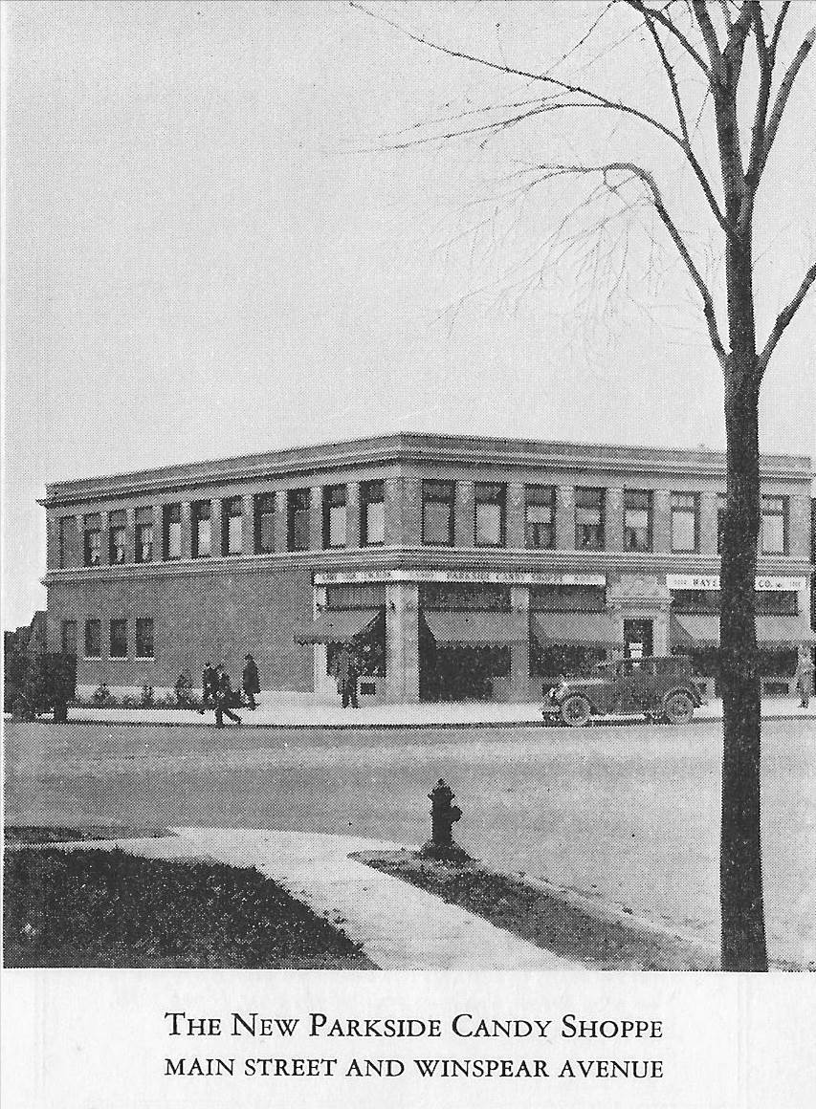
The Parkside Candy Shoppe as it appeared shortly after its construction (ca. 1927)
Source: A Vision Realized. Buffalo: Parkside Candy Company, 1927, page 2.
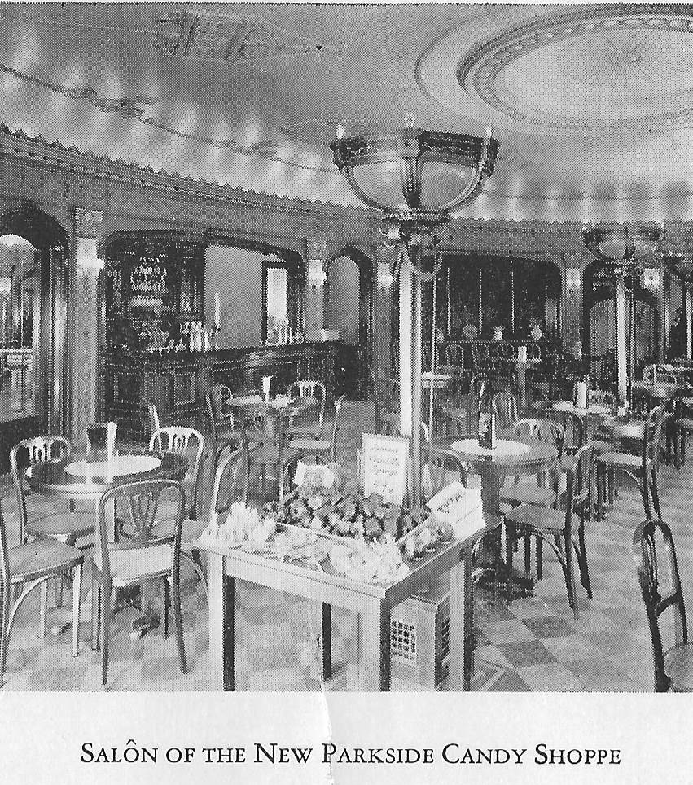

The interior of the Parkside Candy Shoppe as it appeared shortly after its construction (ca. 1927)
Source: A Vision Realized. Buffalo: Parkside Candy Company, 1927, page 6.

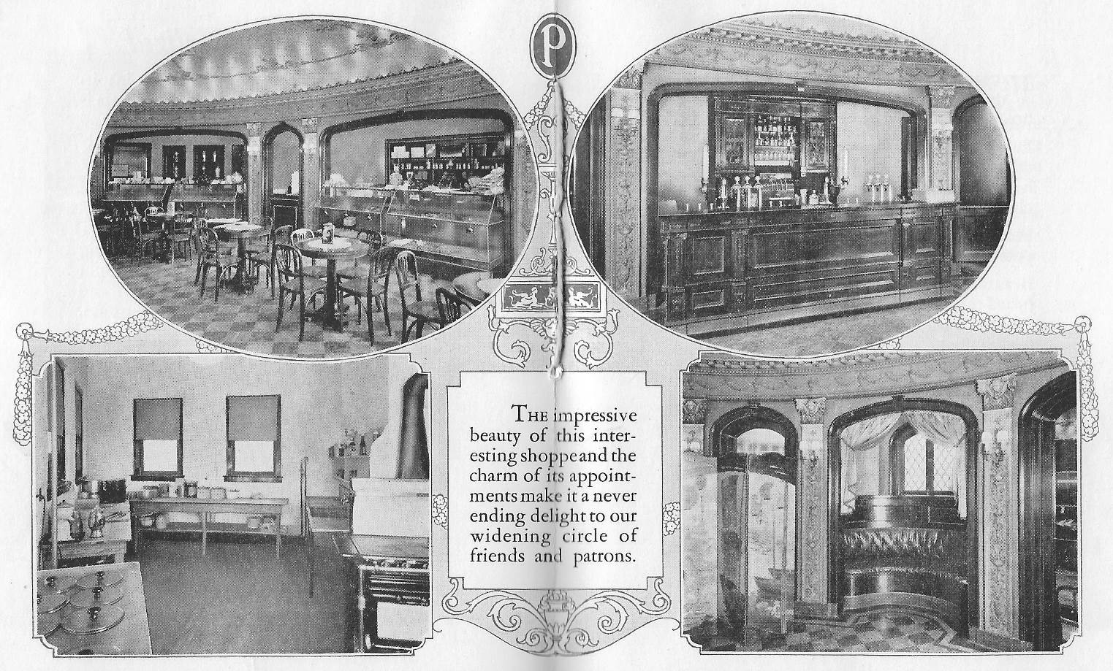

The interior of the Parkside Candy Shoppe as it appeared shortly after its construction (ca. 1927)
Source: A Vision Realized. Buffalo: Parkside Candy Company, 1927.

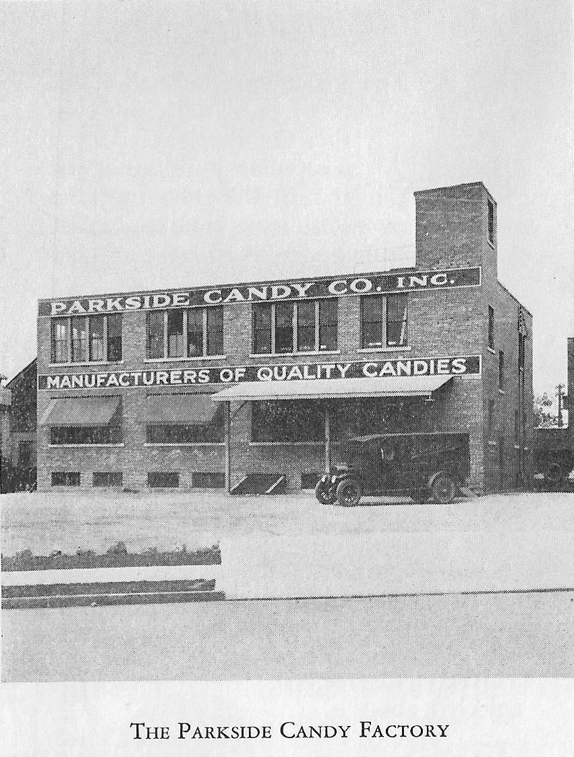

The Parkside Candy Factory as it appeared shortly after its construction (ca. 1927)
Source: A Vision Realized. Buffalo: Parkside Candy Company, 1927, page 12.

Detail, Sanborn Map (1935)

Detail, Sanborn Map (1951)

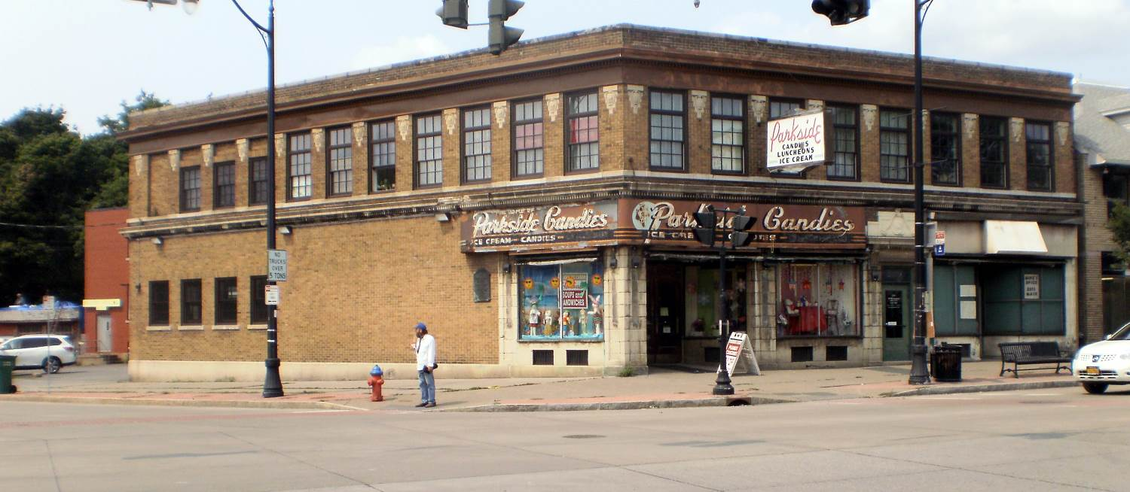

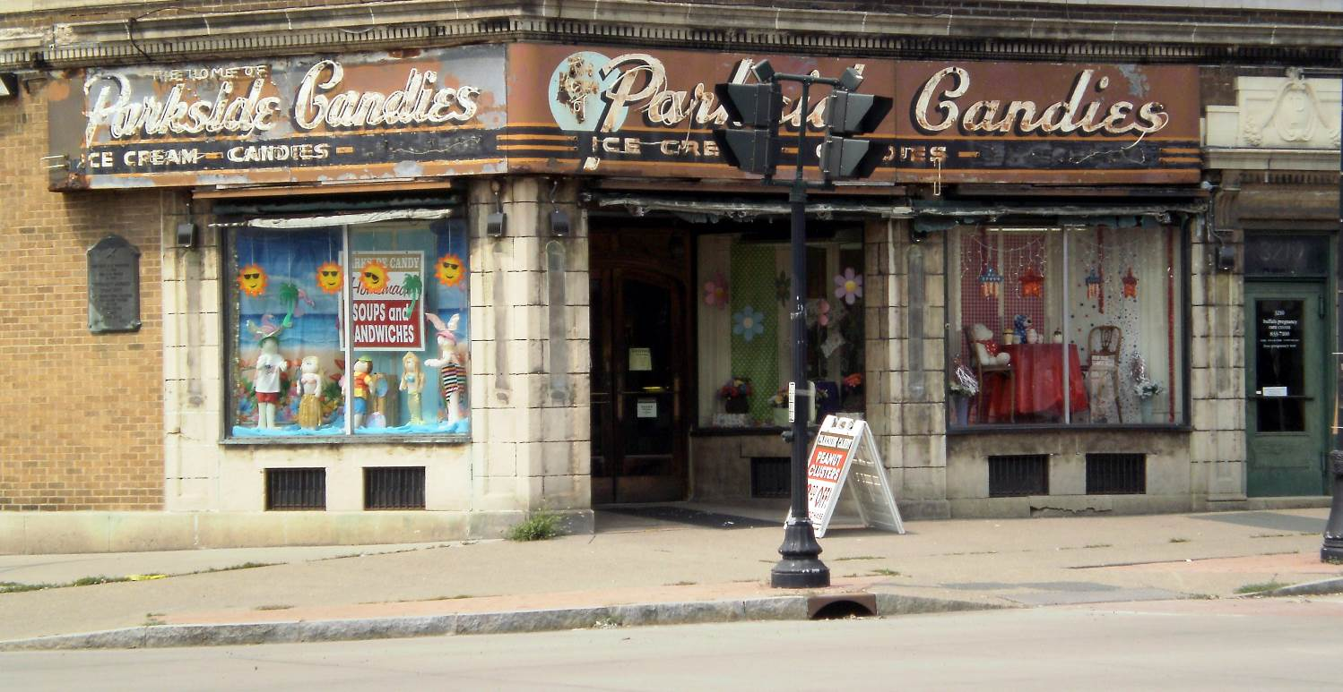

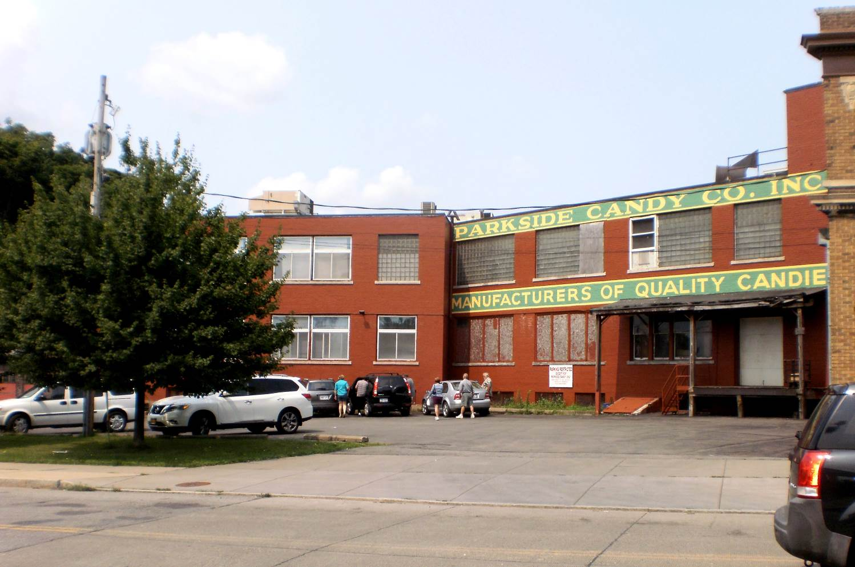

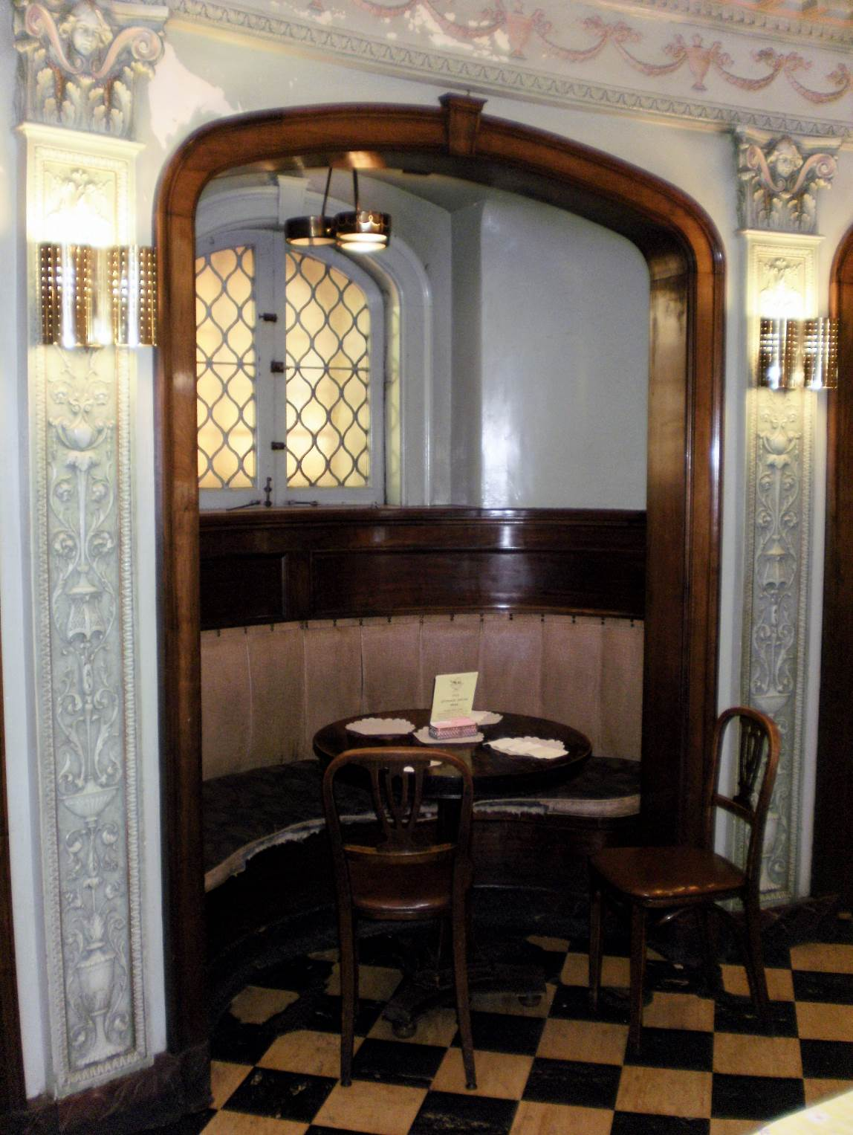

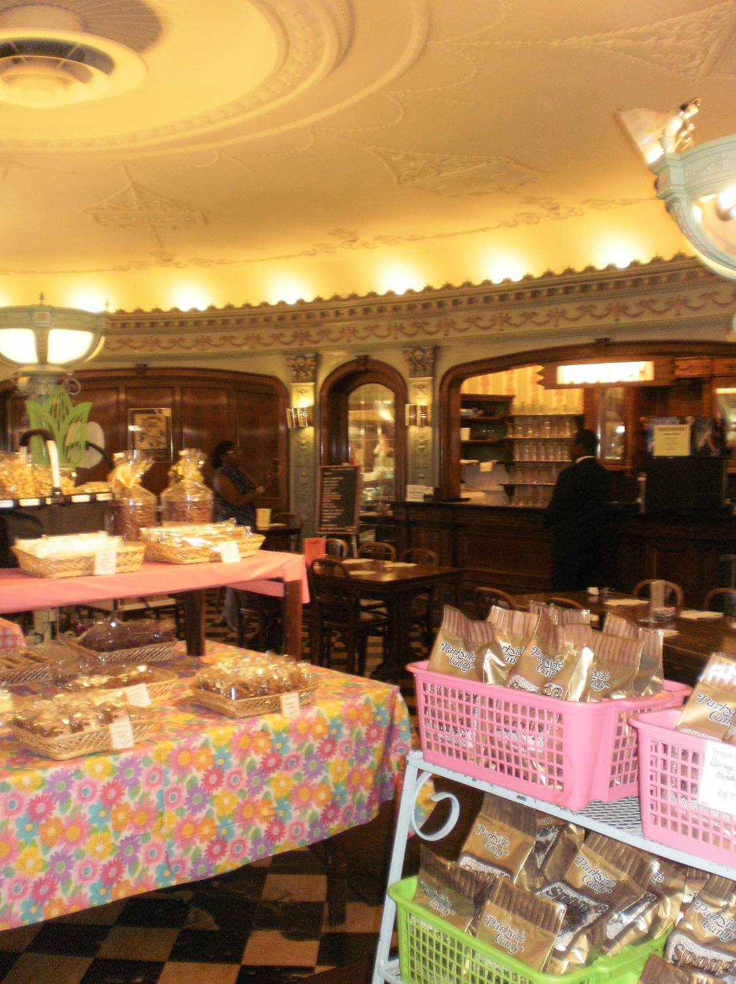

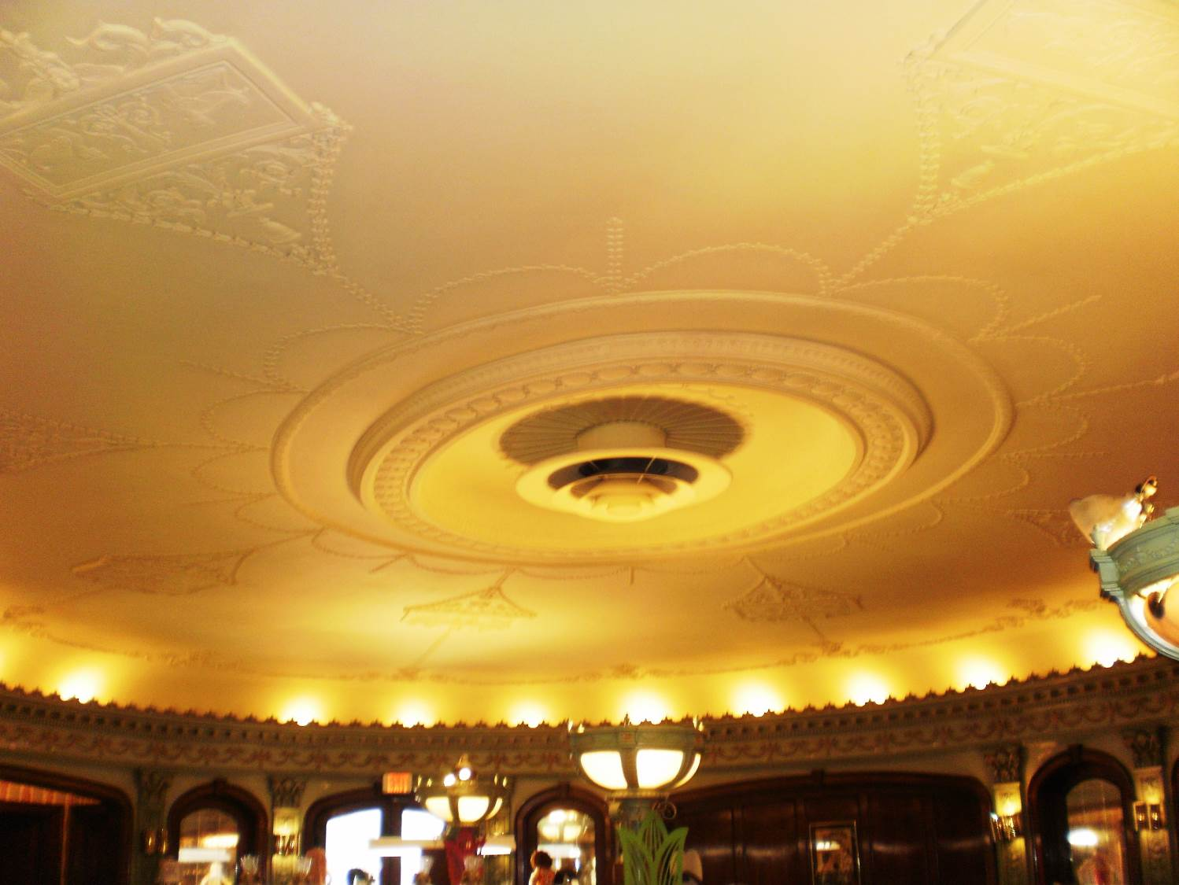

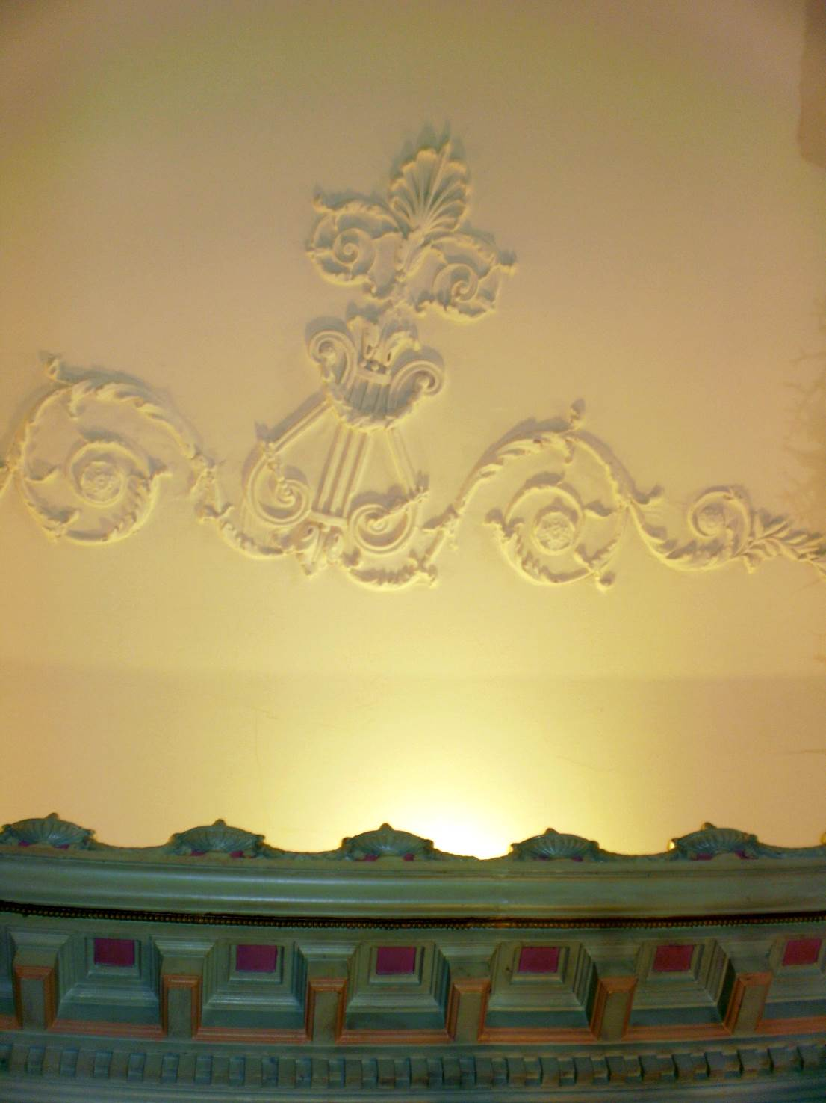

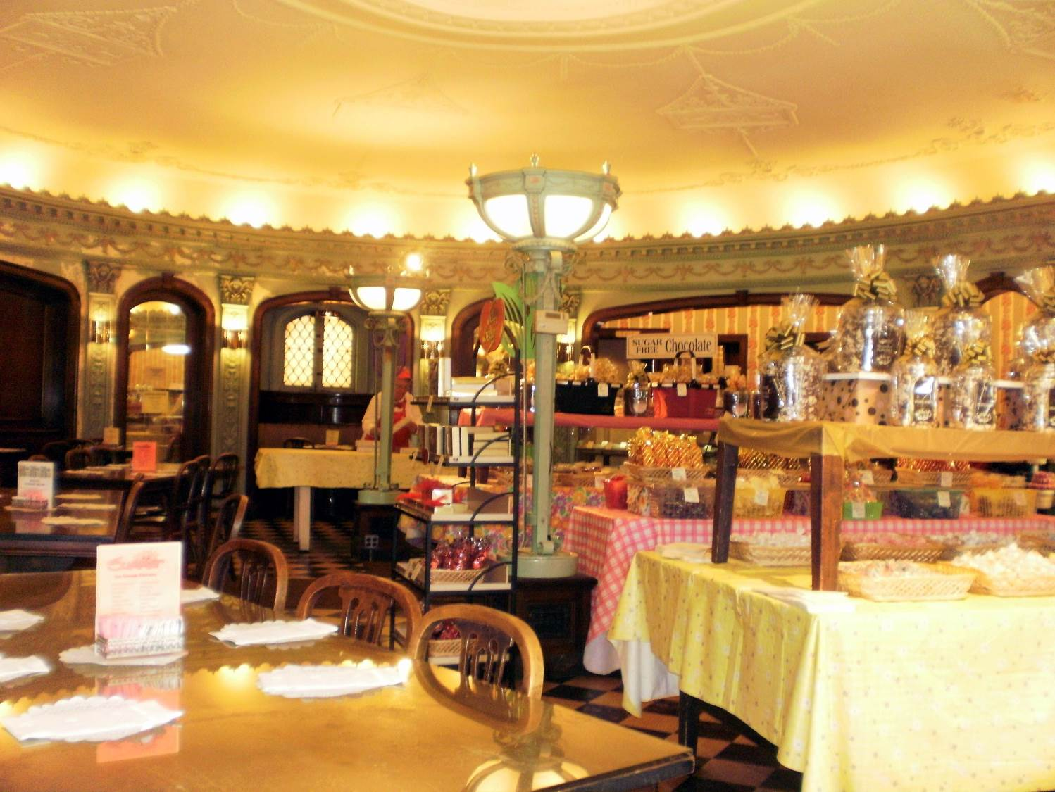

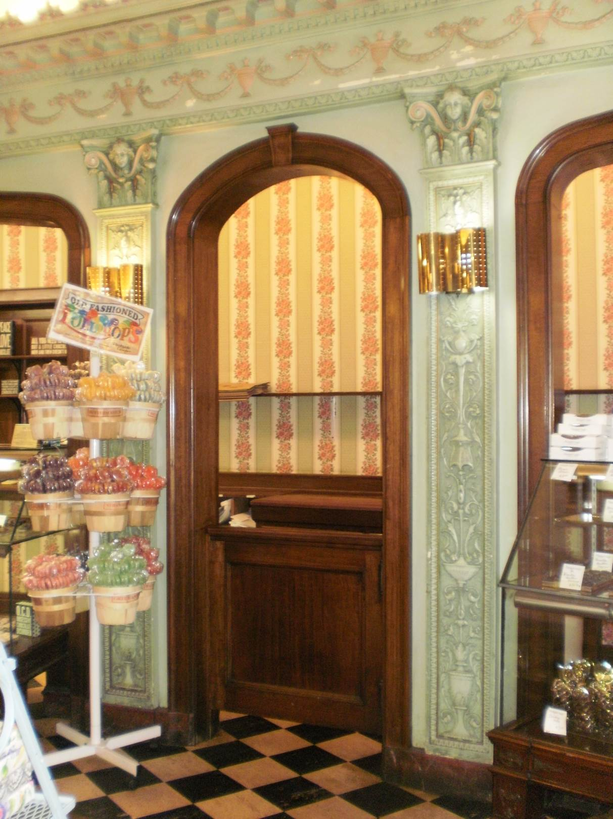
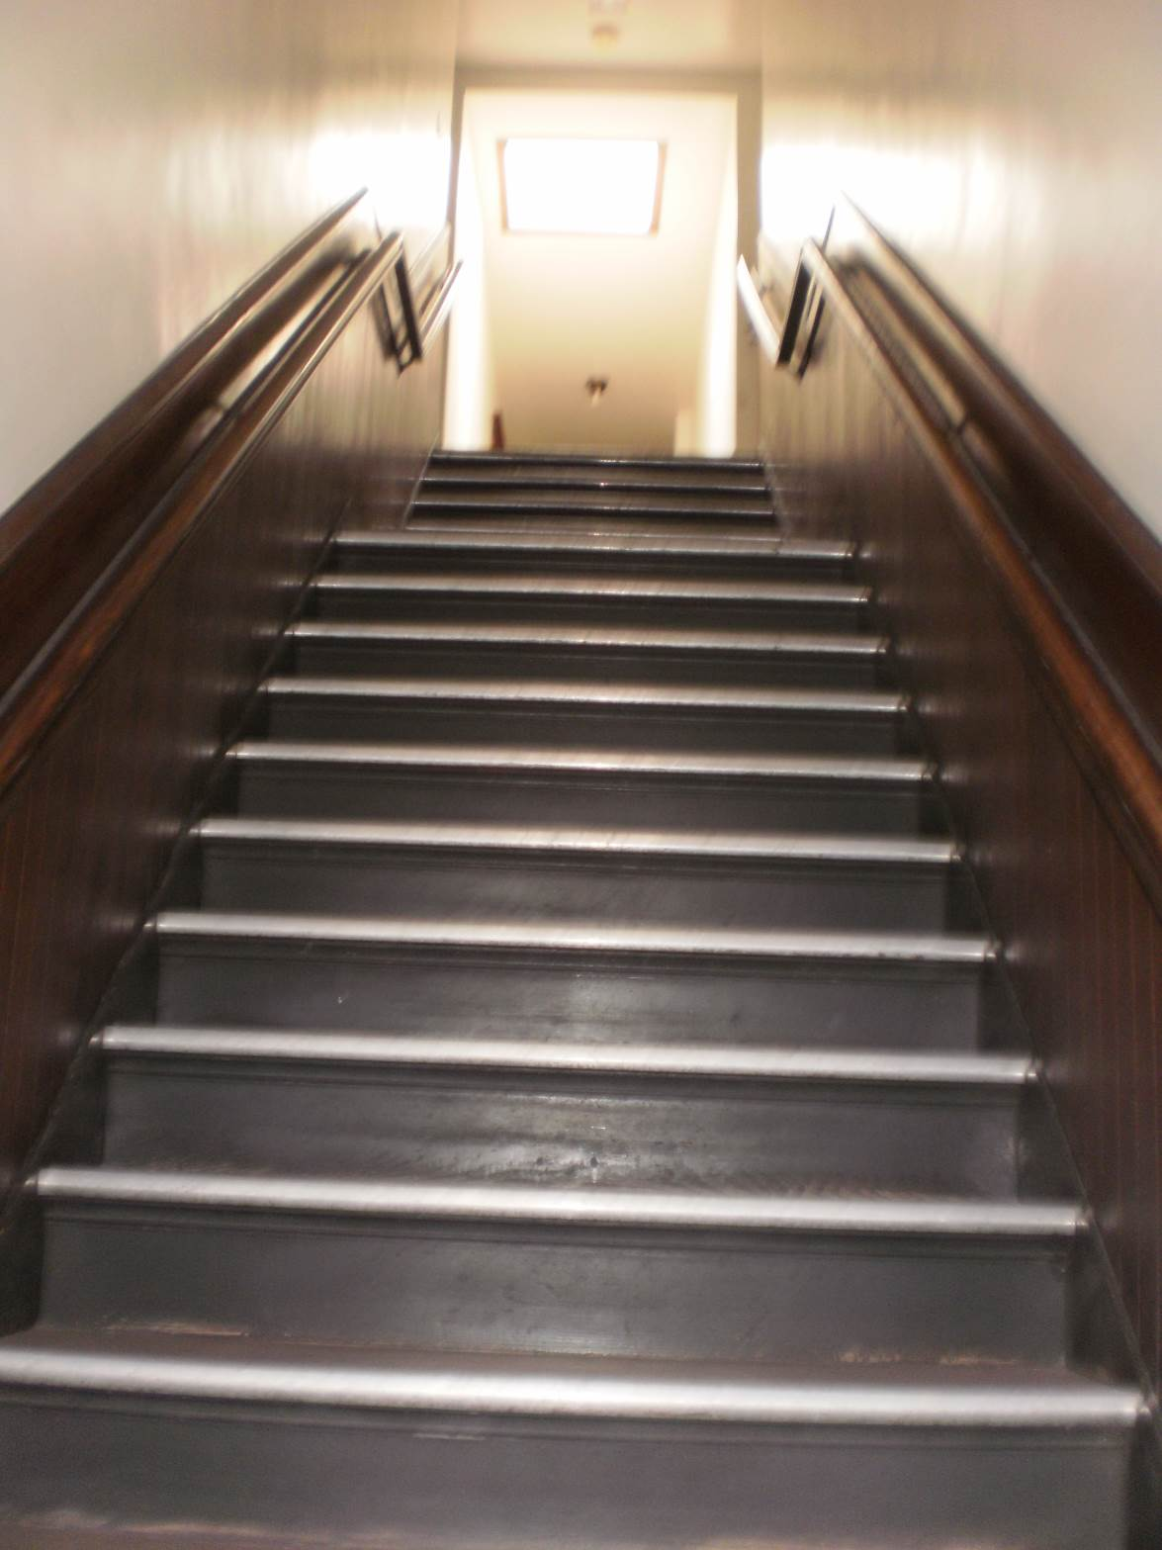

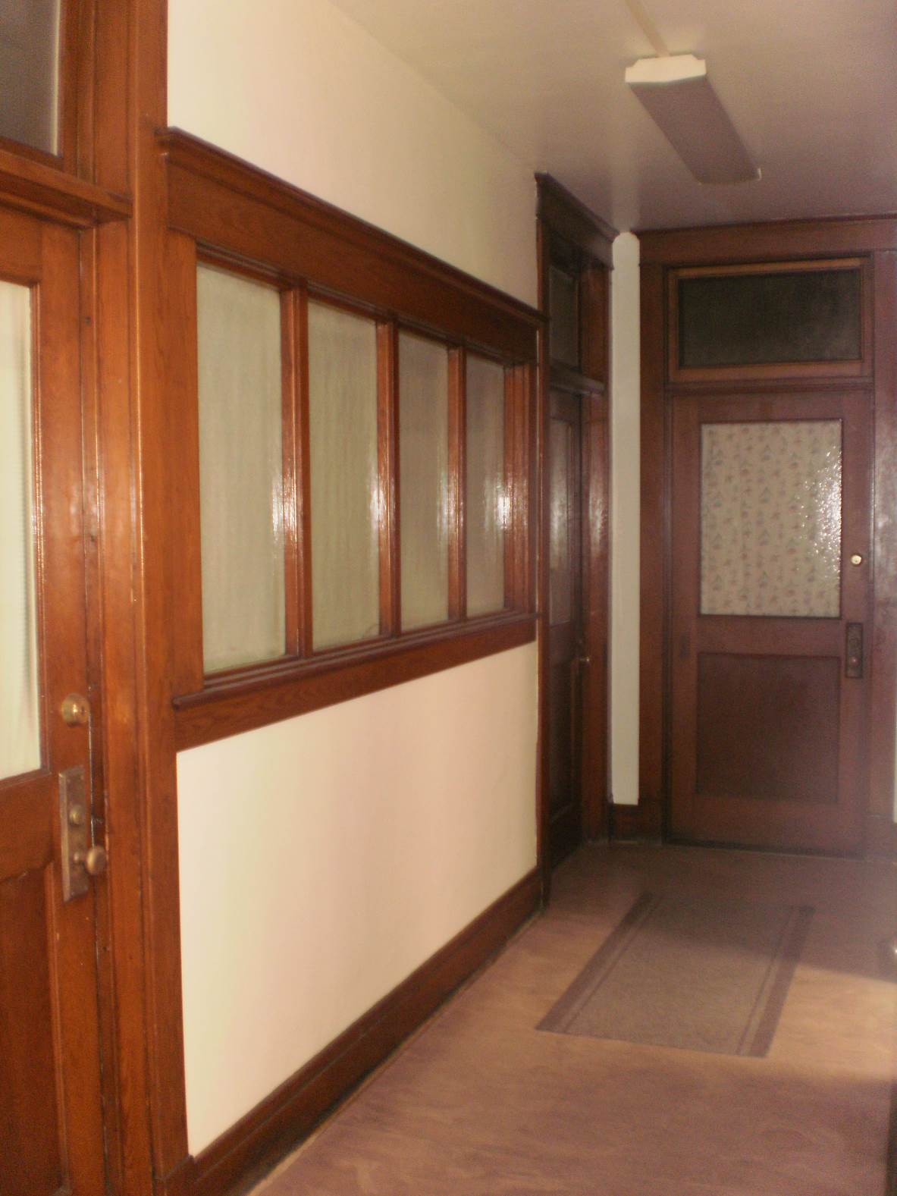

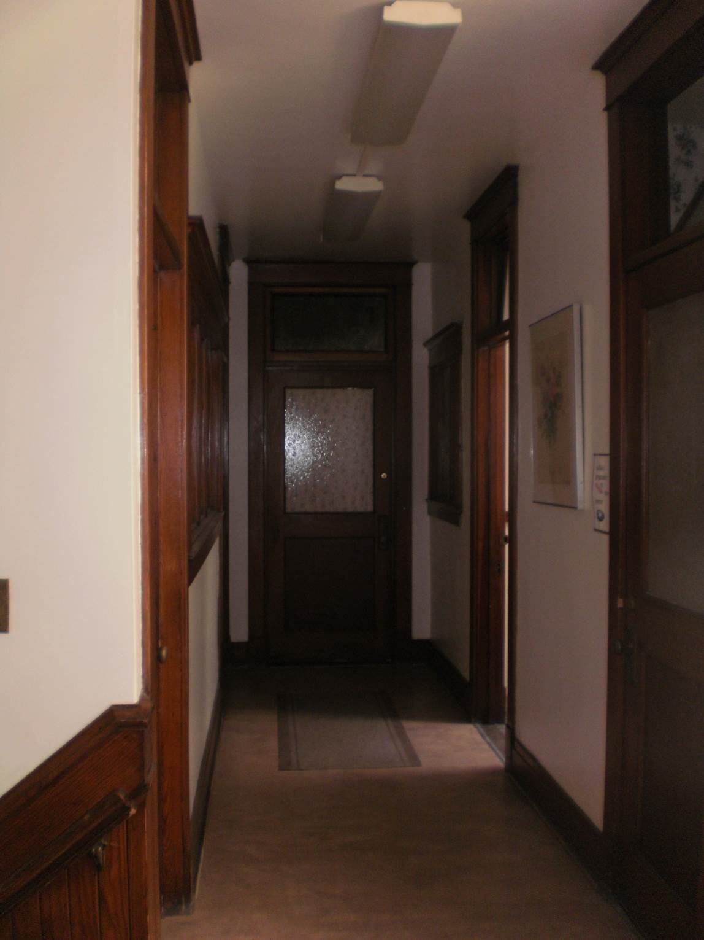

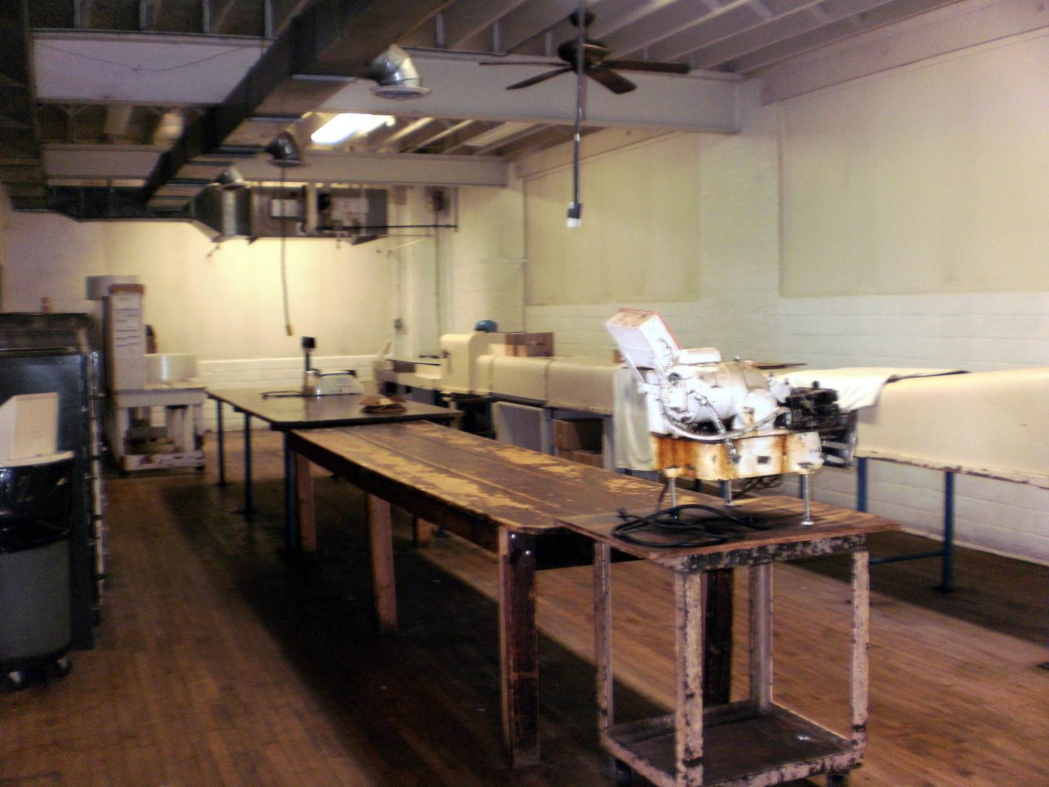

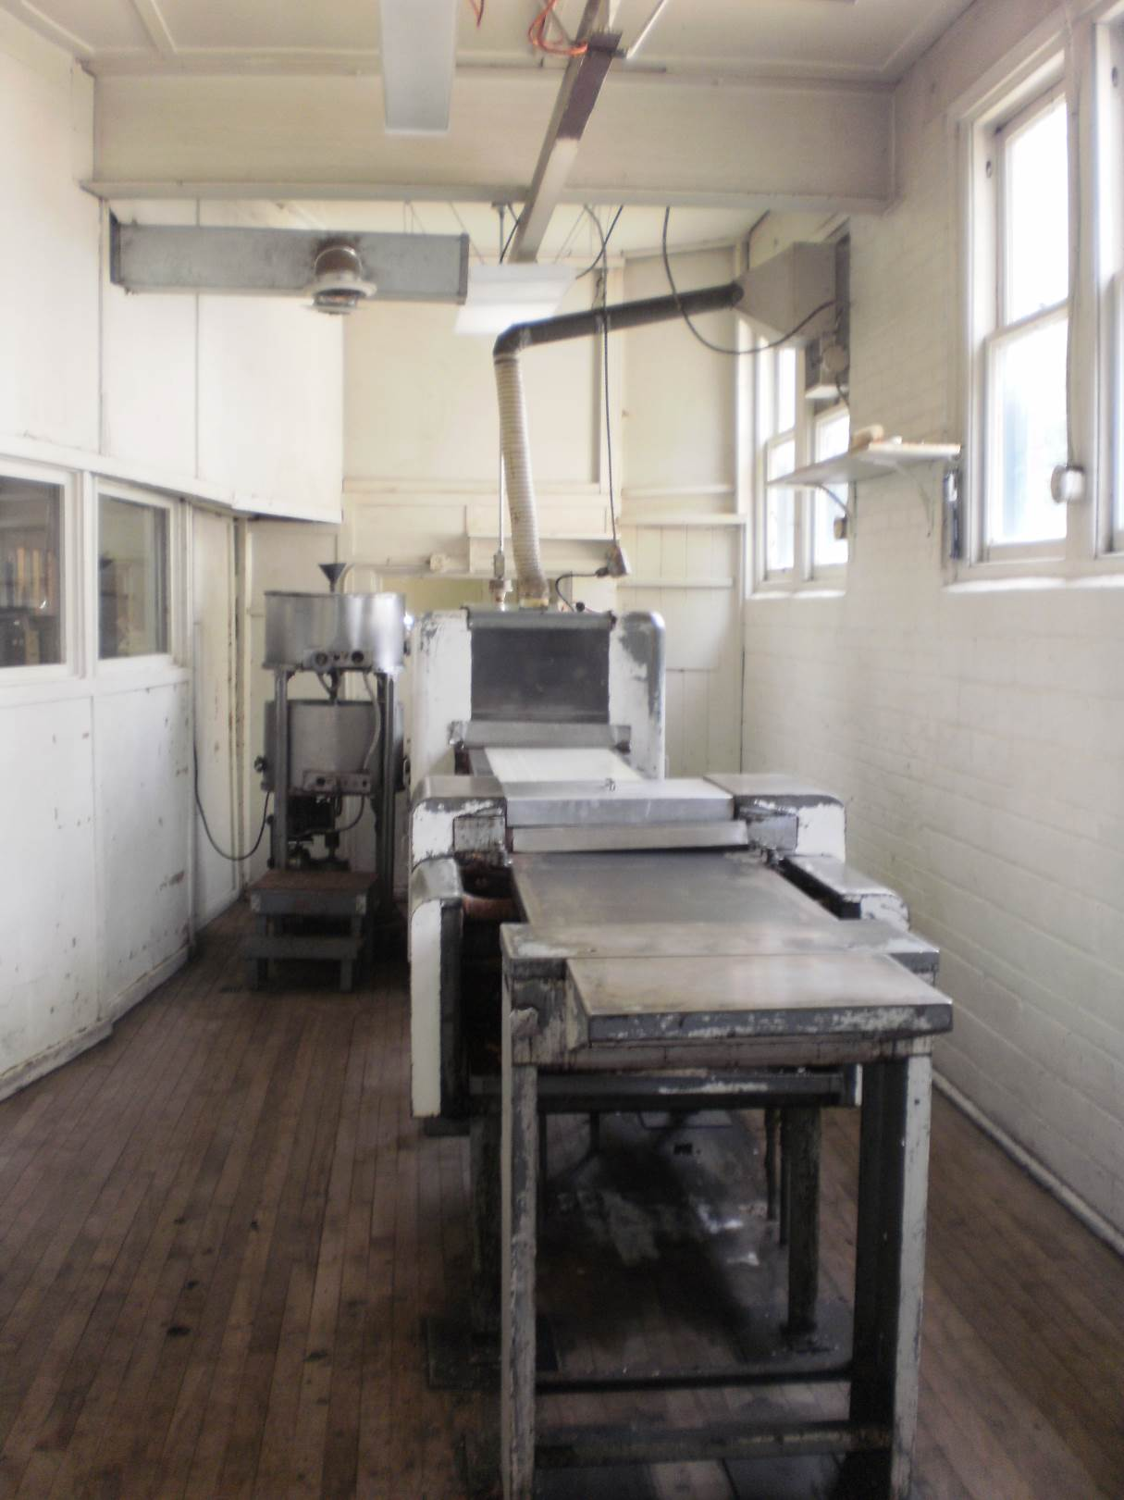

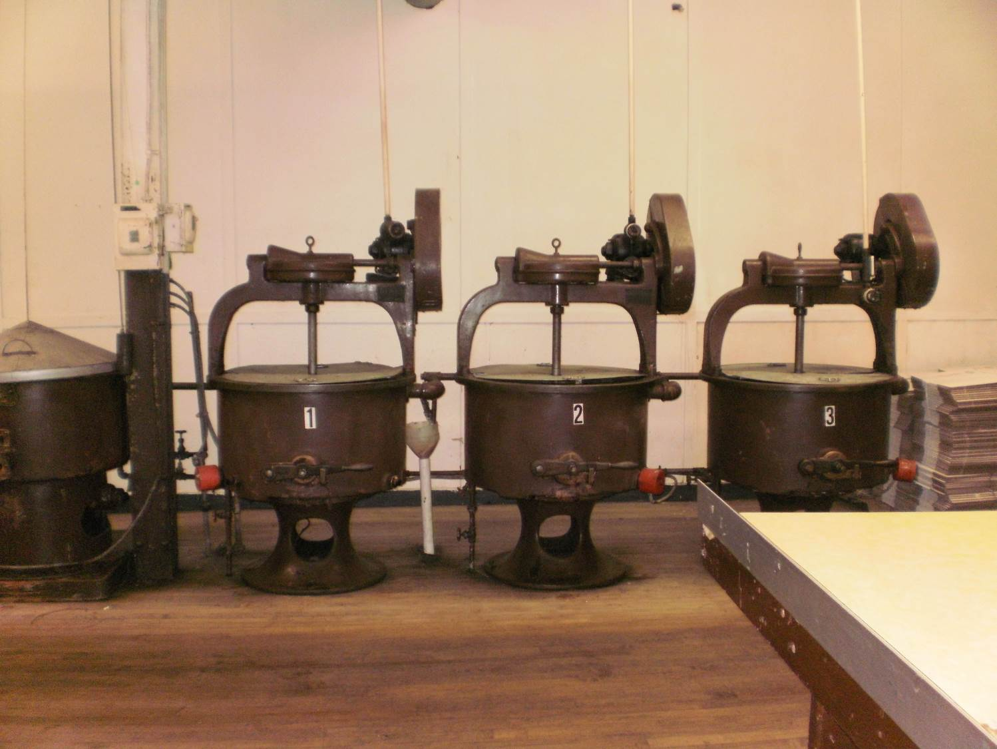

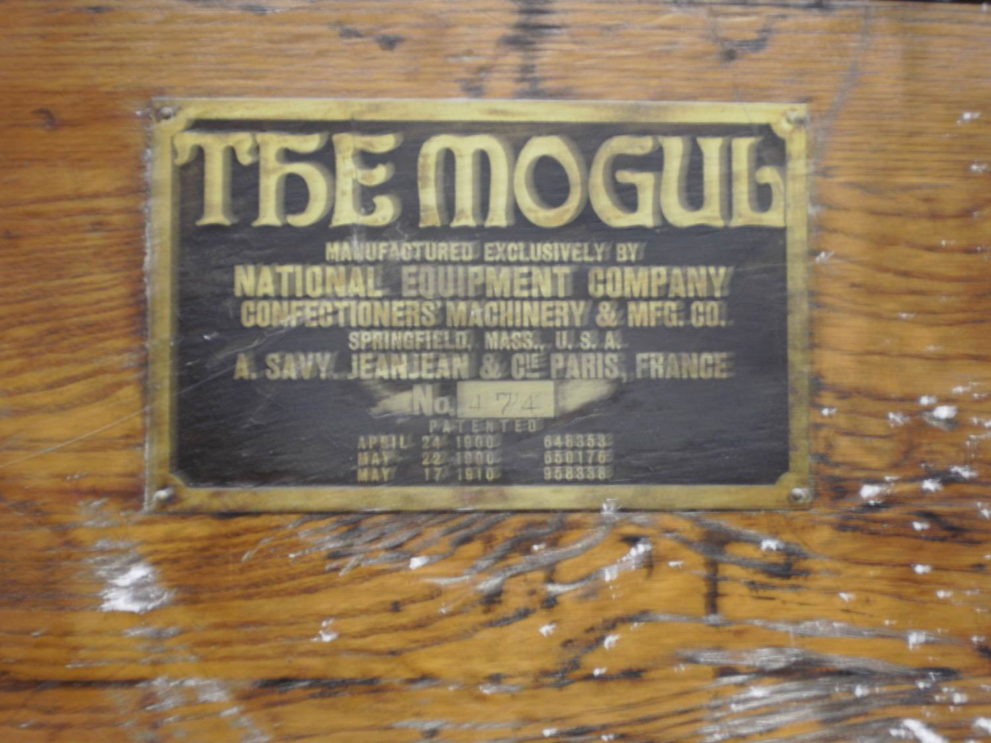

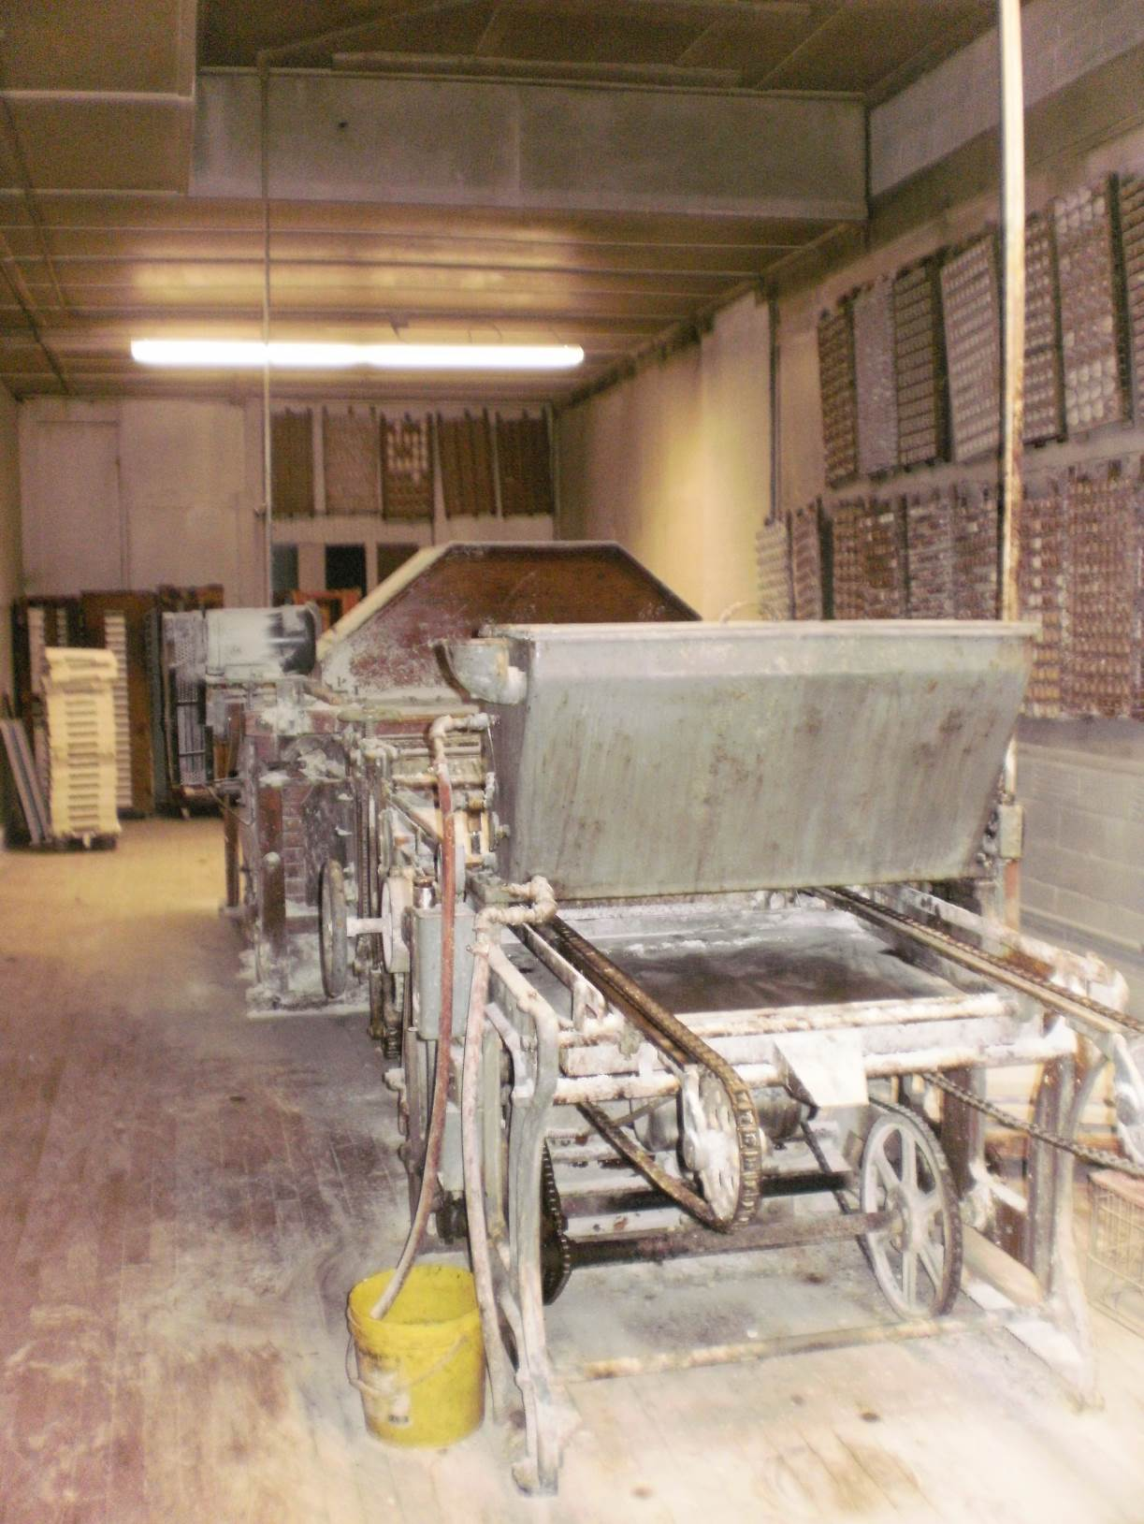

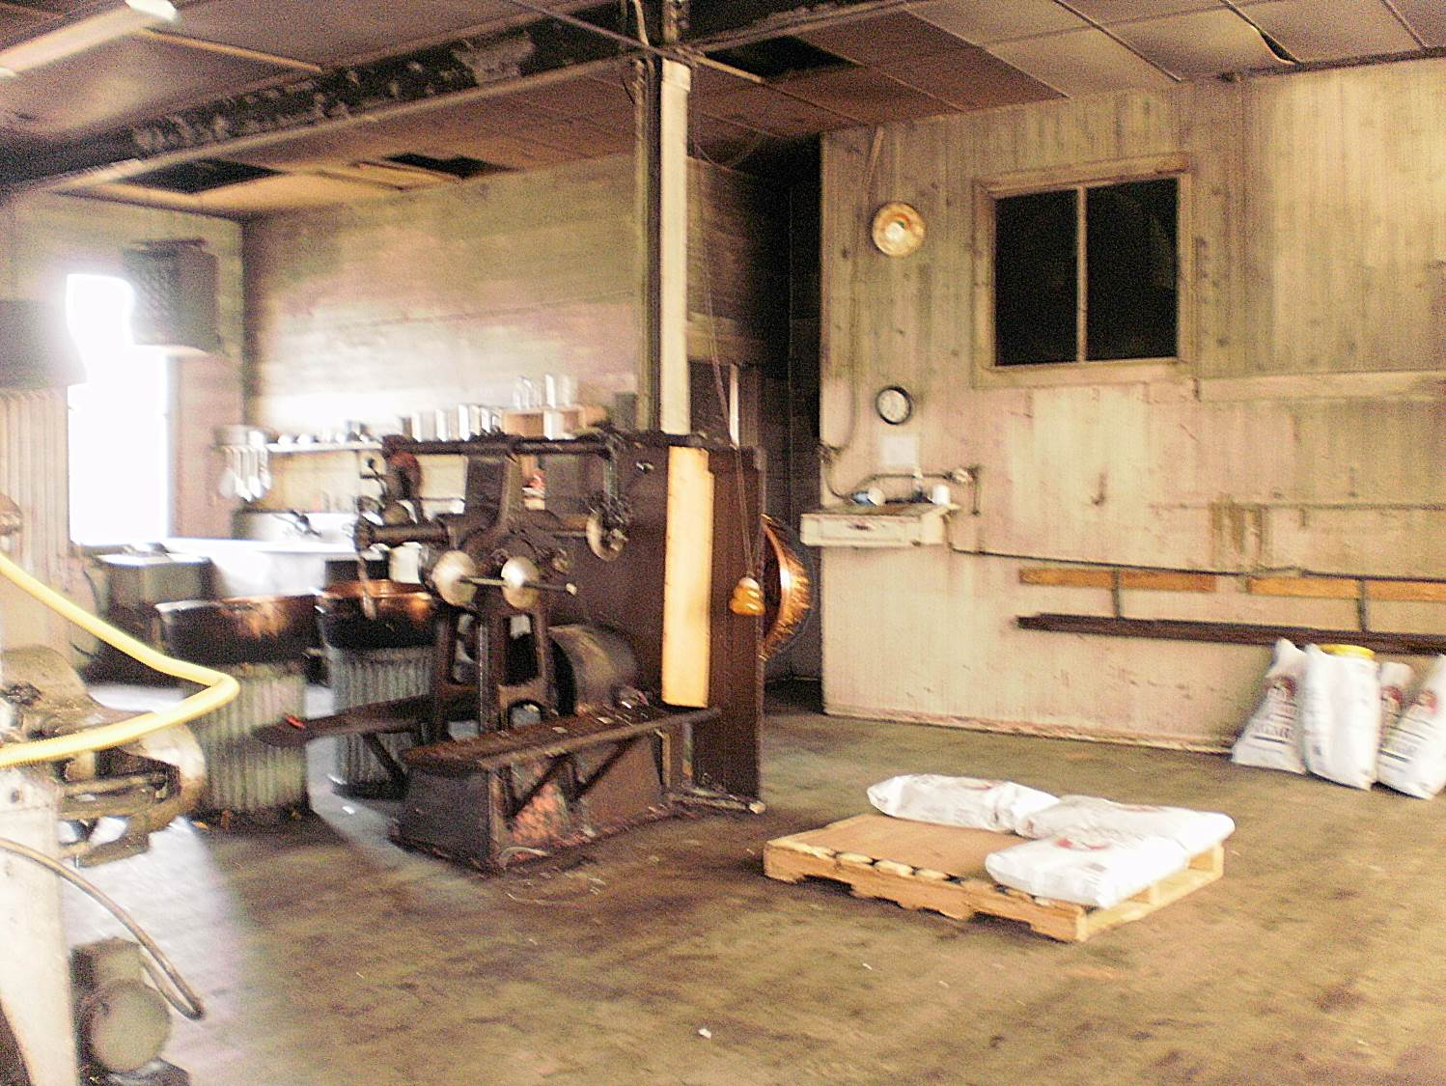

In 1985, the building, which is no longer used as a candy store, was listed as a contributing structure in the Parkside East National Register Historic District.
Between the opening of the first candy store and the construction of the facility at Main and Winspear, in 1921, the family acquired the former Dolly Madison Candy Shoppe at 2 East Eagle Street which it operated under the name of Parkside’s Dolly Madison Candy Shoppe. See “announcement,” Buffalo Evening News, April 6, 1921.
A Vision Realized (Buffalo: Parkside Candy Company, 1927), 10.
A Vision Realized, 7.
Wendy Woloson, Refined Tastes Sugar, Confectionery, and Consumers in Nineteenth-Century America (Baltimore: Johns Hopkins University Press, 2002), 3.
Ibid., 2.
A Vision Realized, 3-4.
“Shop Talk: Far from Town,” Buffalo Courier-Express, October 25, 1939.
“Shop Talk: Fun For All,” Buffalo Courier-Express, January 30, 1939.
“Shop Talk: Evening Rendezvous,” Buffalo Courier-Express, July 10, 1939.
A Vision Realized, 13.
“Opening,” Buffalo Evening News, April 8, 1921.

